

***CWB Architecture***

***CWB Digital Banking   
Technical Solution Design***

|  |  |
| --- | --- |
| **TITLE:** | CWB Digital Banking |
| **REVISION:** | 0.1 |
| **REVISION STATUS:** | Pending review and approval |
| **DATE OF ISSUE:** | 09/14/2020 |
| **DATE OF NEXT REVISION** |  |
| **OWNER:** | Architecture and Service Delivery |
| **CUSTODIAN:** | AMS Manager |
| **ORGANIZATION:** | Application Development |
| **INFORMATION CLASSIFICATION** | Internal |
| **RISK CLASSIFICATION:** | Medium |
| **RETENTION PERIOD:** | RETAIN FOR ONGOING USE |
| **MASTER STORAGE LOCATION:** | SharePoint Project folder. |

|  |
| --- |
|  |

**REVISION RECORD**

Table 1 Revision Record

|  |  |  |  |  |
| --- | --- | --- | --- | --- |
| **Revision** | **Reviewed by** | **Endorsed by** | **Approved By** | **Date** |
|  |  |  |  |  |
|  |  |  |  |  |
|  |  |  |  |  |
|  |  |  |  |  |

**DOCUMENT CHANGE CONTROL**

Table 2 Document Control Change

|  |  |  |  |
| --- | --- | --- | --- |
| **Revision** | **Author** | **Date of Issue** | **Brief Description** |
| Draft | Reinhardt Tonn | Sept 14, 2020 | Document creation |
|  |  |  |  |
| Draft | Hardesh Marwaha | Dec 29, 2020 | Add section items Section 2.6.111,11 2.612 &6.12 and 2.6.13 |
| Draft | Hardesh Marwhah | Jan 08, 2020 | In corporated Reinhardt comments in above sections |
| Draft | George Bogdan | Feb 1, 2020 | Incorporated draft for CRA Direct Deposit (3.5.9) |
| Draft | Reinhardt Tonn | Feb 4, 2020 | Enhanced Context Diagram (3.1), Integration Diagram (3.6.1), Solution Details and Key Decisions (3.5), Technical Architecture (3.8), Data Architecture (3.7) |
| Draft | Reinhardt Tonn | Feb 5, 2020 | Updates to Customer Identity and Access Management (3.5.3), Alerting (3.55), Mobile Remote Deposit Capture (3.5.6) |
|  |  |  |  |

**DISTRIBUTION LIST**

Relevant sections of this document have been distributed to:

Table 3 Distribution List

|  |  |
| --- | --- |
| **Name** | **Role** |
| George Bogdan | Solution Architect |
| Mark Doubinin | Application Solution Architect |
| Vikram Singh | Information Security Architect |
| Dilshad Bhatti | Digital Program Manager |
| Andrew Petesky | Senior Project Manager – Infrastructure |
| Dino Noce | Program Manager – Digital Banking |
| Chix Dela Luna | QA Lead – Digital Program |
| Jack Vaalburg | Temenos/Infinity Architect |
| Damanpreet Singh | Temenos/Infinity Project Manager |
| Bhavesh Jain | Temenos/Infinity Technical Lead |
| Ryan Slack | Integration Architect - Bits and Glass |
| Andy LePage | Integration PM - Bits n Glass |
| Kyle Bergum | AVP, IS Architecture |
| Steve Kelcher | Business Analyst – Digital Program |
| Gerry Weber | Senior Digital Technology and Resource |
| Charlotte Morgan | Senior Functional Analyst |
| Lisa Rindero | Senior Manager, Core Application Services |

TABLE OF CONTENTS

1. Document Summary 8

1.1. Purpose 8

1.2. Objectives 8

1.3. Project Contacts 8

1.4. Intended Audience 8

1.5. Revision and Feedback 8

2. Business – Updates Required 10

2.1. Current State Retail 11

3. Release 1 - Solution Architecture 12

3.1. Context Diagram 12

3.2. Architectural Decisions 13

3.3. Solution Components 13

3.5. Solution Details and Key Decisions 20

3.5.1. PAN-Centric vs CIF-Centric Messaging 20

3.5.2. PAN and Account ID – Solving for Mutable Keys 21

3.5.2.1. Small Business Data Model 22

3.5.2.2. Small Business – Virtual Company Setup 23

3.5.2.3. Small Business - Add T24 User to Virtual Company 24

3.5.2.4. Small Business - Add Delegate to Virtual Company 25

3.5.2.5. Small Business – Get Accounts 26

3.5.2.6. Small Business – Transaction Request 27

3.5.2.7. Retail – Get Accounts 28

3.5.2.8. Retail – T24 Notify of PAN Changes 29

3.5.3. Customer Identity and Access Management 30

3.5.3.1. Login Widget 32

3.5.3.2. Authentication Flow 34

3.5.3.3. Okta Token Usage 36

3.5.3.4. Logout 38

3.5.3.5. Password Change 38

3.5.3.1. Mobile Device Registration & Biometric Authentication 39

3.5.3.2. Quick Balance 40

3.5.3.1. Onboarding – Awaiting Use Cases 41

3.5.3.2. First Login – Awaiting Use Cases 42

3.5.3.3. Factor Sequencing 46

3.5.3.4. SSO Capabilities 47

3.5.4. Transaction History 48

3.5.4.1. Short Term (Anticipated Timeframe: Small Business and Retail Banking) 48

3.5.4.2. Long Term (Anticipated Timeframe: Commercial) 49

3.5.5. Alerting 50

3.5.5.1. R1 Detailed Scope and Solution 50

3.5.5.2. Solution Diagram 51

3.5.5.3. Future Release - Integration Pattern 52

3.5.6. SMS Provider 53

3.5.1. Email Provider 55

3.5.2. Product Level Entitlements 55

3.5.3. CRA Direct Deposit - Draft 55

3.5.3.1. Workflows 55

3.5.3.2. Capture Direct Deposit Information 55

3.5.3.3. Send Direct Deposit to CRA 55

3.5.3.4. Data Elements 56

3.5.3.4.1. Retail Baning Data Elements 56

3.5.3.4.1.1. Data Samples 57

3.5.3.4.2. Business Banking Data Elements 57

3.5.3.5. Data Samples 60

3.5.3.6. File Transfer Frequency 60

3.5.3.7. CRA Connectivity 61

3.5.3.7.1. Test Environment 61

3.5.3.7.2. Production Environment 61

3.5.4. Bill Payment 62

3.5.4.1. Add Payee 62

3.5.4.2. Get Payees 63

3.5.4.3. Remove Payee 63

3.5.4.4. Recurring Add/Create Payment 64

3.5.4.5. Reverse Immediate Bill Payemnts 65

3.5.4.6. Future Dated Bill Payment Add/Create 66

3.5.5. CRA Tax Payments 68

3.5.5.1. Get/Add Tax Payee 68

3.5.5.2. Immediate Tax Filling with Payments 69

3.5.5.3. Recurring/Future Dated Nightly Batch Payment 70

3.5.6. Mobile Remote Deposit Capture 71

3.5.6.1. Messaging Flow 71

3.5.6.2. Kofax Mobile SDK 72

3.5.6.3. Central-1 mRDC Reference 72

3.5.7. Employee Authentiation / Authorization 73

3.5.8. Infinity User Activity Extract/Integration - TODO 73

3.5.9. Fraud Solutions - TODO 74

3.5.9.1. Mobile Security – Pending Security Review 74

3.5.10. New Account Opening – Awaiting Use Cases 75

3.5.11. Bill Pay Master Vendor List 75

3.5.12. Flinks Integration – Post MVP 76

3.5.13. Celero/DOXIM 76

3.5.14. Transfers 76

3.5.14.1. Manage Recipient 76

3.5.15. Data Management 77

3.5.15.1. Address Validation 77

**3.5.15.2.** **Email** 77

3.5.15.3. Lost PAN – PAN update - TODO 78

3.5.15.4. Replicate Customer Details from T24 to Okta – Awaiting Use Cases 78

3.6. Integration Architecture 79

3.6.1. Overview Diagram 80

3.6.2. API Security 82

3.6.3. CloudHub Architecture 83

3.6.3.1. Physical Reference Architecture 83

3.6.3.2. Private Network Architecture 84

3.6.3.3. Network Layer Security 85

3.6.4. Standard Integration Pattern 86

3.6.5. Error Handling Practices 87

3.6.6. Mock APIs for Testing 88

3.6.7. Summary Integrations 90

3.6.7.1. File Based/Batch Integrations 90

3.6.7.2. Real-time Widget/Javascript Integrations 91

3.6.7.3. Real-Time Integrations 91

3.7. Data Architecture and Migration 93

3.7.1. Architectural Guidance 93

3.7.2. Data Placement Diagram 94

3.7.3. Systems of Record & Systems of Usage - TODO 96

3.7.4. Information Classification - TODO 96

3.8. Technical Architecture – In Progress 97

3.8.1. Environment Purpose/Definition 98

3.8.1.1. Project Environments 98

3.8.1.2. Operational Support Environments 98

3.8.1.3. Production Environment 98

3.8.2. Project and Operational Support Environment Diagram – High Level Pattern 99

3.8.2.1. Matrix 100

3.8.3. T24 Project and Operational Support Diagram 101

3.8.4. Technical Infrastructure Overview/Design 102

3.8.5. Infinity 103

3.8.6. Directory and Identity Services 104

3.8.6.1. DNS - TODO 104

3.8.6.2. Active Directory 104

3.8.6.3. User Accounts / Group Name 104

3.8.6.4. Service Accounts - TBD 104

3.8.7. Firewall Rules 105

3.8.7.1. Partner QA, CWB SIT, CWB UAT and Production 105

3.8.8. Certificates 106

4. System Management Design – Updates Required 107

4.1. Monitoring, Logging, Traceability and Incident Management 107

4.1.1. Overview Diagram 107

4.1.2. Logging & API Traceability 107

4.1.2.1. Sequence Diagram 109

4.1.2.2. Sequence Description 109

4.1.2.3. Mule Logging Guidance 110

4.1.3. Monitoring 111

4.1.3.1. Mule – Native Monitoring 111

4.1.3.2. Mule - API Functional Monitoring 111

4.1.3.3. Mule – Alerting 112

4.1.3.4. Mule – SCOM Monitoring 112

4.1.3.5. Mule – ServiceNow Integration 112

4.1.3.6. Mule - Health Check 112

4.2. Log Aggregator Integration 112

4.3. Service Level 113

4.4. Service Priority 114

4.5. Systems Management 114

4.5.1. Application Management 114

4.5.2. Infrastructure Management 115

4.6. Service and Process Automation Capabilities 115

4.7. Business Continuity 115

4.7.1. Backup and Restore 115

4.7.2. Disaster Recovery 115

4.7.3. Data Retention Policy 115

5. Approvals 116

5.1. Prerequisites for Detailed Infrastructure Design 116

6. Appendices 117

APPENDIX A. Infrastructure Servers 117

APPENDIX B. Drive Mapping 117

APPENDIX D. Glossary 119

APPENDIX E. Service Level Objectives Responsibility Matrix 119

References 121

# Document Summary

## Purpose

The purpose of this document is to outline the technical solution design of the CWB Digital Banking, powered by the Temenos Infinity Digital Banking Platform. It includes the technology and infrastructure, system integration, and configuration options for implementation, maintenance and support of the Digital Banking environment.

## Objectives

To configure and implement the Temenos Infinity Digital Banking solution to address the immediate Digital Banking requirements for CWB Retail, Small business and Motive Retail. Subsequent enhancements of this document will address the immediate and long-term solution for CWB Commercial Banking.

## Project Contacts

Table 4 Project Contacts

|  |  |
| --- | --- |
| Roles | Name |
| Project Sponsor: | Christina Mullen  [Christina.Mullin@cwbank.com](mailto:Christina.Mullin@cwbank.com)  Jason Bond  [Jason.Bond@cwbank.com](mailto:Jason.Bond@cwbank.com) |
| Project Lead: |  |
| Project Manager | Jogi Nijjar – Senior Project Manager  [Jogi.Nijjar@cwbank.com](mailto:Jogi.Nijjar@cwbank.com) |
| Business Analyst(s): | Sunil Prashar – Business Analyst  [Sunil.Prashar@cwbank.com](mailto:Sunil.Prashar@cwbank.com) |
| Project Coordinator: | Genevieve Parrent  [Genevieve.Parrent@cwbank.com](mailto:Genevieve.Parrent@cwbank.com) |
| Systems Integration Architect | Mark Doubinin  [Mark.Doubinin@cwbank.com](mailto:Mark.Doubinin@cwbank.com) |
| End user Services: | N/A |
| Security Advisor: | Roney Simon Mathews  [Roney.SimonMathews@cwbank.com](mailto:Roney.SimonMathews@cwbank.com) |
| Infrastructure Manager: | Darren Bryks  [Darren.Bryks@cwbank.com](mailto:Darren.Bryks@cwbank.com) |
| Infrastructure Analyst: |  |
| Database Admin: | N/A |
| Solutions Architect(s): | Reinhardt Tonn  [Reinhardt.Tonn@cwbank.com](mailto:Reinhardt.Tonn@cwbank.com)  Hardesh Marwaha  [Hardesh.Marwaha@cwbank.com](mailto:Hardesh.Marwaha@cwbank.com) |
| Application Manager |  |

## Intended Audience

This document is to be used by the applications development and infrastructure operations team to assist in the creation of the release plan for the implementation of the applications, servers, storage and networking components.

## Revision and Feedback

This is a living document and should be revised and updated periodically to reflect changes as they occur in the CWB IT infrastructure environment.

# Business – Updates Required

The key goal of the Digital Program is to implement Digital Client Onboarding processes and be a disrupter in offering unique online banking products and services for Personal, Small Business, and Commercial clients for Motive Financial and and Canadian Western Bank customers.

The first key project phase is Motive and Personal Digital Client Onboarding (DCO), which includes new front-end web pages (using Temenos Infinity) for prospective personal clients to select a product, enter their personal data and submit a request for approval. New back-end capabilities utilizing specialized services from thirdstream (a fintech broker) and internal capabilities to CWB will be developed to facilitate identity validations, AML and fraud checks and customer/account creation processing without human intervention. Exception processing will be supported with some manual intervention using a sophisticated employee facing portal.

**Key Objectives:**

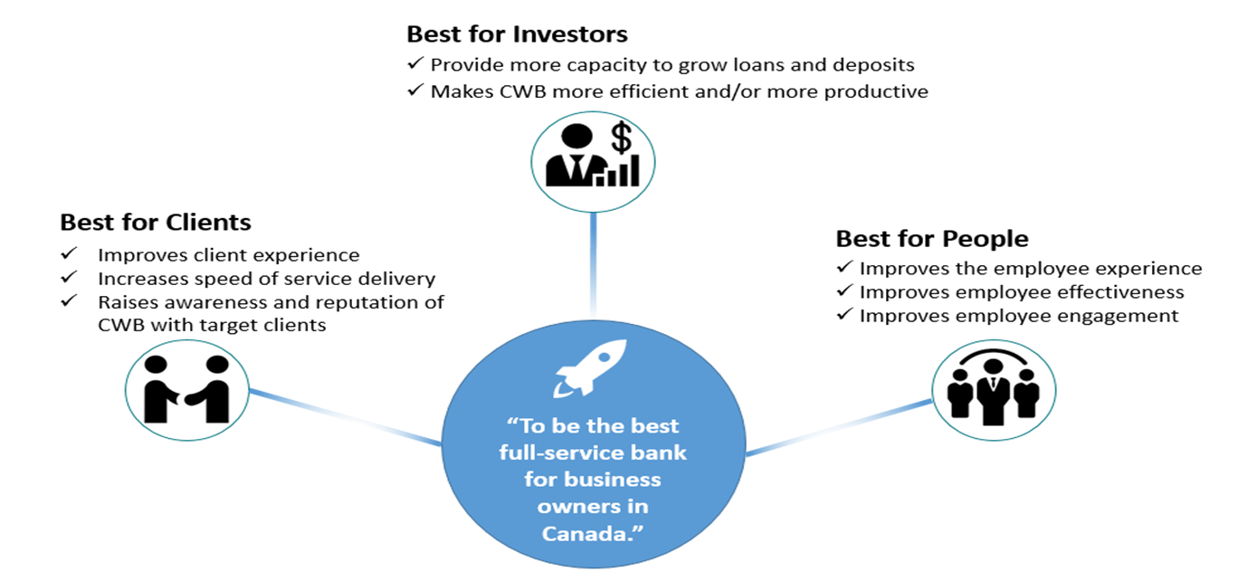

**Best for Investors:**

* Attracting new clients which will increase loans and deposits will benefit investors.
* Reducing manual efforts that are currently required to open new accounts will improve efficiency and productivity.

**Best for Clients:**

* The modern and distinct products/services that will be delivered by the Digital Program will improve client experience though improving the functionality of the online systems, and offering clients tools they don’t have access to elsewhere.
* Digital Client Onboarding will offer personal and small business clients a much faster way to open a new account remotely, which will benefits prospective new clients who are outside of CWB’s current geographic branch footprint.

**Best for People:**

* Reducing manual efforts required by CWB staff will improve the employee experience and allow them to focus on more value-add activities.
* Staff are clients of the bank, and will benefit from the improved experience that will be delivered by the personal changes in the Digital Program, and in particular the enhancements to personal online banking.

## Current State Retail and Small Business

The following diagram represents the current state of CWB’s motive, retail and small business channels.



# Release 1 - Solution Architecture

## Context Diagram



## Architectural Decisions

|  |  |  |  |
| --- | --- | --- | --- |
| **Name** | **Responsible Party** | **Purpose** | **Location** |
| Okta and Client Application Authentication | Reinhardt Tonn  Vikram Singh | To formalize authentication user experience for CWB client facing applications | [Sharepoint](https://sp.cwb.local/departments/is/is/architecture/Lists/Architecture%20Artefacts/Attachments/24/Architectural%20Decision%20-%20OKTA%20and%20Client%20Applications.docx) |
| Password Change Solution Options | Reinhardt Tonn | Select a secure user change password option. |  |
| Transaction History Search Solution Options | Reinhardt Tonn | To formalize the transaction history search architecture. | [Sharepoint](https://sp.cwb.local/departments/is/is/architecture/Lists/Architecture%20Artefacts/Attachments/22/RFDxxx%20-%20Architectural%20Decision%20-%20Digital%20Banking%20-%20Transaction%20History%20Solution%20Options%20v0.2.docx) |
| Alerting Solution Options | Reinhardt Tonn | To formalize the component responsibilities with respect to alert triggering. | [Sharepoint](https://sp.cwb.local/departments/is/is/architecture/Lists/Architecture%20Artefacts/Attachments/23/RFDxxx%20-%20Architectural%20Decision%20-%20Digital%20Banking%20-Alerting%20Solution%20Options%20v0.1.docx) |
| Communications Provider | Reinhardt Tonn | Formalize the SMS provider for the digital program. |  |
| PAN-Centric vs CIF-Centric Messaging | Reinhardt Tonn | Formalize the use of PANs for retail and small business and CIF for commercial banking. |  |
| Mobile Remote Deposit Capture SDK | Hardesh Marwaha | Select a vendor for the mobile capture of cheque images | [sharepoint](https://sp.cwb.local/departments/is/is/architecture/Lists/Architecture%20Artefacts/Attachments/42/Mobile%20Capture%20Platform.pdf) |
| Mobile Device Registration | Vikram Singh |  |  |

## Solution Components

|  |  |  |
| --- | --- | --- |
| **Component** | **Status** | **Responsibilities** |
| Customer Channels | New | Customer and Employee facing digital banking experience hosted on the Infinity Platform.  This is comprised of several notable components:  ***Online Banking***  Targeting desktop user devices, this component is responsible for the digital banking experience.  ***Mobile Banking***  Targeting ios and android mobile devices, this component is responsible for providing a **native** digital banking experience. Some elements of the solution, such as widget integrations with Okta and future integrations with Flinks and CWB’s credit card providers will be browser based, leveraging the hybrid capabilities of the Infinity Platform  ***Contact Centre***  (See Digital Banking Internal Experiences) |
| Identity and Access Mgmt | New | Okta is CWB’s customer facing Identity and Access Management solution.  **Authentication Widget**  A Widget provided by Okta that based on Okta policy will provide the authentication user experience. This widget will challenge users with standard username/password credentials, collect an MFA factor if not yet registered, challenge a user with MFA if required by policy and the user has registered a factor and return OIDC tokens to the client application (i.e. Online banking, mobile banking) to confirm the has authenticated and is authorized to access the channel. Okta will send notifications to users via email to inform of various security events.  **MFA**  Okta supports a wide variety of MFA factors. The widget will collect an MFA factor at time of first login and will challenge with this factor during subsequent logins. |
| Legacy Customer Channels | Enhanced | **Central-1 Online and Mobile Banking**  Although not depicted in the target context diagram, these channels will be used by CWB customers until they have migrated to the new digital banking experience. These solutions will be utilized to communicate to existing customers that some but not all users have been migrated and they will block access for migrated users. |
| 3rd Party Experiences | New  New  Existing  Enhanced | **Okta Widget**  The Okta Widget is an embedded 3rd party experience in the Digital Online Banking and Mobile banking solution. The experience is solely driven by Okta and policy defined within CWB’s customer tenant.  The Okta widget will also be utilized for employee authentication into Spotlight. This is connected to the CWB workforce tenant and is supported by policy specific to employees.  **mRDC SDK**  This SDK is an embedded 3rd party experience in the Mobile banking solution. The SDK supports intelligent capture of cheque images.  **CWB Public Site**  The public site will continue to be used for various content that is common between the unauthenticated site and the Infinity Digital Banking experiences. Information such as FAQ’s, branch locator, ATM locator will reside on the public site.    **Digital Client Onboarding**  The DCO solution developed in parallel with the Digital Banking solution will be utilized for existing customers to onboard new accounts. The solutions are independent but must share a common Okta user session to reduce the need for a customer to log in to DCO if they are already in an authenticated session. |
| Digital Banking Internal Experiences | New | **Infinity Spotlight**  The Spotlight application caters to multiple types of internal users, including but not restricted to:   * Lines of business * Customer service * Digital banking team (manage products, static content, transaction queues, and so on) * IT/Security team   The purpose of this application is to set up and maintain customer and employee-related information and to configure the behavior of digital banking applications associated with this information. The application holds key data around user profiles and static content, and is also designed to interface with various back-end systems. For example, spotlight is utilized to configure or interact with the customer for the various functions:   * the small business virtual company, users assigned to the virtual company and entitlements. * Terms and Conditions * Read and respond to secure messaging   **CSR Assist**  This component allows a CWB employee to perform specific actions in the selected customer's online banking account on behalf of the customer when requested. Customer's consent is required to use this feature. |
| Temenos Infinity Platform | New | The platform on which the Digital Banking application is built. The platform is composed of the following key capabilities:  **Authentication**  The Digital Banking solution will present the Okta Widget for authentication purposes. This ties in with Infinity IAM capabilities to create an application session based on the OIDC tokens received from Okta.  **Device Registration**  This feature registers the mobile phone or tablet for mobile banking. Registering a device allows enables additional mobile features such as Account Preview and biometric authentication.  **Dashboard**  After successfully logging on, the app displays the retail, small business or hybrid dashboard depending on the type of user logging in. Only entitled accounts are shown, which for small business requires a post filtering of the accounts retrieved from T24 via the PAN.  **Account Details**  This feature presents account details for a selected account.  **Transactions**  Displays the list of recent transactions linked with an account, grouped by the transaction type (Transfer, Deposits, Checks, etc., and represented as tabs) with date, description, type, category, transaction amount, and account balance details. The list is sorted by date (most recent transaction on top) by default, and certain fields have the sorting option. The tabs change based on the selected account type. All account search capabilities are provided via the Mule API in conjunction with account and date range searches against T24. Mule is enabling the filtering of transactions based on additional criteria.  Transaction Scheduling is presented in Infinity, but all scheduling is supported via T24 core banking functionality.  Print and Download capabilities utilize similar Mule APIs to retrieve the information and then render it accordingly.  **e-Statements**  The provider for e-Statements is Celero/Doxim, and all all related functionality to search and retrieve e-statements is done via a new API defined for this purpose. Infinity presents the information accordingly.  **Transfers**  Release 1 transfer functionality is limited to:   * Transfers to user's own accounts in the same bank * Transfers to other members of the same bank   The actual storage and triggering of recurring transfers is supported directly by T24.  Transfer recipients are not supported by T24 and will be housed in the Infinity solution.  E-transfers are supported via the Central-1 enabled e-transfer API. Interac will continue to hold all of the meta-data associated with e-transfers.  **Payments**  Bill Payment functionality, management of bill payees, scheduling of bill payments (including one-time future dated) and viewing of bill payment history all resides in the T24 component and will be enabled via APIs. Infinity’s responsibility is to facilitate the user experience.  **Locations**  The native capilities of Infinity will not be utilized to present Branch and ATM information. The solution will provide a hyperlink or redirection to the pages hosted on the CWB public site.  **Profile Management**  View and manage various profile details:   * Profile Settings – Various customer details will be updated via Infinity, but the system of record will be T24. See Data Architecture and Migration section for detailed mapping. * Security Settings – Security settings are the responsibility of Okta and will be managed through the Okta Widget, and Okta Admin Portal. Future releases will build out further self-service capabilities with Okta that will require Infinity UI elements and API integration. * Account Settings – account preferences are managed and stored within Infinity. This includes default accounts, and nicknames. * Alert Settings – alert settings are managed and stored in Infinity. Security alerts for MVP are a tenant level configuration in Okta and will not require subscription within Infinity. Other alerts, including new bill payee, new etransfer recipient and approval workflow alerts are handled directly by Infinity for MVP. In the future, financial alerts will be generated by T24’s alerting module and communicated to customers through Infinity.     **Alerts and Messages**   * Alerts generated by the system based on your alert preferences are displayed in the Notification Center. Alerts can be interactive and can navigate the user to the relevant module where an action can be taken. For example, a low balance alert can route the user to the account details page to review account transactions. * The Messaging module is a central place for creating, sending, viewing, and managing all the messages that are sent between the customer and CWB. CWB employees will respond to these messages using Spotlight.   **Pre-Login Account Preview (aka Quick Balance)**  This feature permits a user to view their account balances on the login screen. This feature is available only in mobile banking application and must first be preceded with device registration. The mobile device will store the OIDC refresh token to facilitate retrieval of an Okta access token that will then permit retrieval of these details in a pre-authenticated state.  **Remote Deposit Capture**  This feature permits the user to capture an image of a cheque and deposit this amount to their account of choice. The capture of cheque images will be facilitated with a mobile SDK licenced from Kofax. The posting of the cheque is through Central-1 and T24 APIs.  **Logs**  All actions performed by a CWB employee via Spotlight or CSR Assist will be logged in Infinity for audit purpose. Spotlight provides an option to view these audit logs along with all the logs for the transactions that the customer makes using digital banking applications.  **Approvals & Requests**  This feature allows small business users to view the list of pending transaction approvals they must approve and the transaction requests they raised that needs approval. This is fully managed within the Infinity platform and does not require integration with any other party.  **User Management**  This feature is used by a customer with admin privileges to view the list of enrolled business users, add new business users, and manage them. These users can access the permitted business accounts among the business accounts associated with the company in the banking application, and perform the required activities based on the permissions given by the owner to the business user. The User Management feature is available to only those users who are given explicit permission to manage users. This is managed exclusively in the Infinity platform. Pre-requisites for the user management include the creation of T24 Customer records, signers, the creation of a virtual company in Spotlight and assignment of entitlements to an administrator. Users with a T24 record are searched for and retrieved from T24 to associate their CIF record in Infinity. Delegates without T24 records can be created directly in Infinity but are associated with the admin user that created them. All delegate functionality that results in a call to T24 utilizes the context (CIF, PAN) of the user that created them.  This feature set is duplicated across Spotlight and Infinity.  **Engagement Services**  The Digital Banking Platform (DBP) Engagement Services enable the Infinity Platform to configure and send push notifications and emails based on the occurrence of certain business events. This includes the ability to send emails, SMS, push notifications (to mobile device) and In-App notifications. SMS will be supported through CWB’s partnership with Twilio and a Short-Code is being acquired for these types of SMS communications. All email communications will be through CWB’s SMTPs provider Proof Point. None of these integrations require Mule integration.  **Customer Service & Administration (aka Spotlight)**  At a high-level, Spotlight provides the following capabilities:   * Employee Management. Create and manage employee accounts along with their roles and permissions for using the Spotlight application. * Customer Management. View and manage customer profile details as required; assign groups and entitlements to manage the retail banking application behavior for individual or group of customers. * Application Content Management. Configure the static content displayed in the end-user applications like Terms and Conditions, Privacy Policies, etc. * Master Data Management. Creation and management of the master list of information like customer care centers, bank/ATM locations, list of services offered by the bank in digital banking applications and more. * Reports and Logs. View and maintain activity logs for employee and customers on digital channels, summary reports for activities and transactions. * Customer Service. Capability to view and respond to messages sent by customers; view and update customer profile. Select administration users who have the capability to remotely login on behalf of customers (via CSR Assist) and help them with their online banking troubleshooting. * Dashboard. Landing page with the summary of messages received and information useful for employees.   **Entitlements**  The entitlements module enforces what a small business is authorized to do. This can be applied at a role level and further refined at a user level. Infinity is directly responsible for enforcing:   * Transaction Limits * Period Limits * Group/Role Entitlements * Services/functions assignment * Accounts access |
| Enterprise Integration (Mulesoft) | New (API development) | Integration platform for APIs. Utilized to build out 3 layers of APIs:  **Experience APIs**  Innovation and ease of integration with consuming applications  **Process APIs**  Agility and new value creation  **System APIs**  Unlock assets and decentralize access. System APIs developed during this project phase will include T24, thirdstream and Flinks. |
| External Providers | New  New  Existing API, New Integration  Existing API, New Integration  New API, New Integration  New  New Celero API  New | **Fraud Prevention**  ***Navaera EnScreen ESP***  EnScreen ESP is a high-performance event stream processing (ESP) platform that will monitor digital banking events via advanced stream analytics. By analyzing digital banking events in real time, the system enables CWB fraud stakeholders to respond to events and deal with threats as they occur. Initial focus will be placed on e-transfer and bill payment fraud scenarios, but will be continually extended to build rules that enhance CWB’s ability to detect and prevent fraud.  **Central-1**  ***Bill Payment / CRA Tax Payment***  Central-1 will provide Bill Payment and CRA Tax Payment APIs. Detailed sequence diagrams are found in the Solution Details and Key Decisions section of this document.  ***E-transfer***  Central-1 will provide e-transfer APIs that integrate with Interac on behalf of CWB. Central-1 will continue to provide fraud related capabilities related to e-transfers. Detailed sequence diagrams are provided by Central-1 and will be followed for this initiative. However, any unique deviation, such as how e-transfers are received during the period where some users are migrated and others are not are captured in the Solution Details and Key Decisions section of this document.  ***Remote Cheque Deposit***  Central-1 will provide Remote Deposit Capture APIs. Infinity (in conjunction with the Kofax SDK) will capture high quality cheque images via the mobile application and send the results to the Central-1 API for processing. Detailed sequence diagrams are found in the Solution Details and Key Decisions section of this document.  ***Delegate Authentication API***  Delegate credentials are stored at Central-1. The first login experience for delegates through the Infinity platform will rely on their current credentials. These will be authenticated through the Delegate Authentication API provided by Central-1.  **Additional Providers**  **SMS Provider (Twilio)**  Twilio is a Communications Platform as a service (CPaaS) provider CWB has selected for SMS communications. Infinity will integrate directly with CWB’s Twilio account for sending alerts to CWB customers that have subscribed to various events. A short-code is being established to Twilio to ensure a high quality experience for CWB customers, reduced carrier filtering and high throughput in the event this communication channel is adopted by a significant number of customers.  **Statements and Cheques (Celero/Doxim)**  Celero/Doxim currently stores all “on-us” cheques for CWB. A direct relationship will be established and APIs developed to allow Infinity (via Mule) to retrieve cheques and electronic statements for a customer.  **CRA (Direct Deposit)**  A direct relationship is being established with the CRA to support the direct deposit functionality. Details are found in the Solution Details and Key Decisions section of this document. |
| Internal Providers | Enhance (New SOAP Messages as required)  Existing (new access point)  Enhanced  New Integration | **T24 Transact Core Banking**  T24 Transact is CWB’s core banking system, supporting both Motive and CWB customers and accounts. This application is the system of record for all customers, accounts and funding. T24 will be enhanced to support SOAP services to facilitate functionality that cannot be supported through existing ISO8583 messaging.  **Proof Point**  CWB’s Proof Point instance serves as an external facing secure SMTPs relay. Emails generated by Infinity, are routed through Proof Point to the internal email capabilities of CWB.  **SIEM/Logging (Helix)**  CWB centralized logging and SIEM platform. Digital Banking logs will be sent to this platform for analysis on potential security incidents and other potential cyber threats. The specific rules and data consumption needs are driven by the SecOps team.  **SAS AML**  SAS requires the event log for all employee and customer facing interactions with the Digital Banking platform. |

## Solution Details and Key Decisions

### PAN-Centric vs CIF-Centric Messaging

T24 supports PAN-Centric messaging for retail and small business use, and CIF-centric messaging for commercial use. The CWB architecture team feels that the PAN-centric model is restrictive for several reasons, including but not limited to:

* PAN’s are not immutable and can change when cards are lost. This can result in lost data in systems relying on the PAN as a reference.
* Reissuance of a PAN for the purpose of access to online banking comes with a cost
* PAN’s impose entitlements that are better suited to advanced entitlements modules typically found in Digital Banking platforms
* Typically the CIF is utilized by Digital Banking platforms to link to a user record.
* PANs in T24 are in some cases associated to the personal CIF of a different person to support access for roles such as Power of Attorney, Guarantor, etc. The lack of a reference to the personal CIF of the actual PAN holder means that the actual holder of the PAN is unknown.

Despite these challenges, the PAN is engraned in the messaging created for the Canadian market and is not easily changed, nor does the project support the necessary timelines to address this issue.

It is recommended the current project continue with the PAN-centric messaing, but that CWB target a shift to CIF-centric messaging during the T24 upgrade, which will most certainly address the legacy messaging based on ISO8583.

CIF-centric messaging will be adopted for the Commercial channel.

### PAN and Account ID – Solving for Mutable Keys

There are two values in the current Central-1 and CWB retail/small business online banking architecture and ISO messaging that are mutable. The target architecture requires immutable values as a general dependency to solve for entitlements, preferences and any other data that may be persisted in the Digital Banking platform. The current state mutable values are as follows:

* PAN - The PAN is in most cases the debit card for an individual that has been given authorization to access the accounts via online banking. In some cases this is a virtual number not directly associated with a physical card. The PAN can and does change when cards are lost or need to be replaced. Today, the PAN is used by the user when logging in and this is directly authenticated by T24.
* Account ID - The ISO8583 messaging between CWB for retail and small business relies on an account identifier that is a compound key, comprised of the BIN, Branch (mutable), Category (mutable), Currency, Product Type (mutable) and Product Number (mutable) and the last 8 digits of the PAN. This account identifier is returned to the channel when accounts are retrieved that are associated with the PAN.

In the current architecture with Central-1 and CWB, there appear to be some cases where the PAN is utilized to store information at the channel level. There is a process supported by Central-1 to update old PANs to new PANS. CWB does not currently take advantage of this process. This suggests there must be some use cases where CWB users experience some loss of information that is persisted using the PAN value.

In the target architecture, CWB has introduced Okta as an identity provider and the Infinity Digital Banking platform from Temenos. Infinity has the requirement for stable, immutable keys to retrieve accounts associated with a customer, and for the accounts returned for the customer so that preferences, entitlements, etc. can be associated to these accounts.

The diagrams below show how CWB will continue to utilize much of the ISO messaging that relies on the mutable values (PAN, Account ID), but provides immutable values to the Infinity platform.

* Account ID – this value is replaced with what is known as the Legaci MDI value in T24.
* PAN – this value will be derived based on the company CIF and the Personal CIF

#### Small Business Data Model

* Infinity Small Business –introduces the concept of a virtual company to which accounts from 1 or more physical CIFs in T24 are associated. Users are then created and entitlements assigned to govern what the user can do with each account. The association to the account must be through an immutable identifier. Although not currently utilized or exposed in retail or small business ISO messaging, the T24 core banking system has an immutable value called **Legacy MDI**. This is available across all retail, small business and commercial accounts. The solution data model below and the solution diagrams that follow utilize this value in the RESTful messaging, providing a stable/immutable value to the channel.
* Mule – the integration layer will take on a responsibility of mapping the immutable values to theire mutable equivalents. The PAN will be derived using the Business CIF and the Personal CIF, and the **Legacy MDI** value to **Account ID** value relationship will be cached for reference in all messaging that requires it. Caching will be leveraged to ensure optimal performance.
* T24 – for both retail and small business, T24 relies on the PAN to enforce access to accounts. All retail/small business ISO requests require the PAN as input. Accounts are represented by an ISO Account ID, but they are also referenced by the Legacy MDI.



#### Small Business – Virtual Company Setup

The following process and supporting APIs represent what is done in Infinity when a Virtual Company is manually created. Much of this can be automated by the initial migration process and the ongoing Digital Client Onboarding process; however, there will likely always be a need for a manual creation of companies in Infinity/Spotlight.

The GetAccount service will be enhanced to utilize the Business CIF and also to return the **Legacy MDI** value (immutable) for each account. Using a CIF for this process will ensure it doesn’t differ for the future commercial offering, since PAN is not part of the commercial solution.



#### Small Business - Add T24 User to Virtual Company

The following process and supporting APIs represent what is done in Infinity when adding a T24 user (represented by their personal CIF) to a Virtual Company via Spotlight.

A service will be built to verify that the Personal CIF being added has an active PAN associated to the Business CIFs added to the Virtual Company. Additional information is also retrieved from the Personal CIF. This process will need to Create an Okta User record (supplying details from the CIF) and assign the entitlements (associating the user to the immutable **Legacy MDI** value).



#### Small Business - Add Delegate to Virtual Company

The following process represents what is done in Infinity when adding a delegate user to a Virtual Company. This can be done by the administrator of a Virtual Company. When adding the delegate, the personal CIF of the administrator will be assigned to the delegate user. This will ensure that all communications via ISO messaging will carry the administrators CIF (resolving to the administrators PAN). A delegate cannot transact directly without approval from a signer. An Okta record must also be created, but there will be no CIF or PAN associated to this Okta record. All updates to user details (e.g. name, email, phone#) is done through Infinity UIs and updated via Okta APIs.



#### Small Business – Get Accounts

In order to resolve to the PAN required in CWB’s ISO messaging, CWB’s messaging will be enhanced to derive the PAN from the Personal CIF and the List of Business CIFS the user is entitled to access. A new service will be built to derive the PAN, and the derived PAN will be sent to the existing service to retrieve accounts based on the PAN. Mule will leverage caching where possible to ensure the process to derive PANs happens infrequently within a user’s session. Infinity will post-filter the accounts returned to ensure only entitled accounts are shown to the user. Mule will also cache the relationship between the Legacy MDI and the Account Identifier so that subsequent requests using the Legacy MDI will quickly be mapped to the appropriate Account Identifier.



#### Small Business – Transaction Request

In order to resolve to the PAN required in CWB’s ISO messaging, CWB’s messaging will be enhanced to derive the PAN from the Personal CIF and the List of Business CIFS the user is entitled to access. This service will take advantage of previously cached information (at the Mule layer) to map immutable values identifying the customer and the business CIFs to the PANs required for the transaction, along with a mapping of the immutable Legacy MDI value to the ISO Account Identifier. Once these values are derived, standard ISO messaging will be leveraged.



#### Retail – Get Accounts

Access to retail accounts is dependent on the PAN. It cannot be derived from existing immutable values, as in the Small Business use case. The value will be stored on the Okta record and passed to Infinity at time of login.

Since this mutable value will be stored in Okta, CWB will need to solve for the case where the PAN changes. This is addressed in the following section.

Much like the small business solution, the immutable **Legacy MDI** value will be utilized to reference accounts, since the Infinity platform will also store preferences for retail accounts (e.g. favourite accounts, nicknames, etc.).



#### Retail – T24 Notify of PAN Changes

Referencing the PAN in Okta is problematic, but necessary to communicate which PAN the user is authenticing against when supplying their Okta credentials (username and password). Therefore, when the PAN changes in T24, Okta will need to be updated with the new PAN.

For the first release, this could potentially be done through manual business process. Any update of the PAN in T24 will also require a manual update of the PAN to the appropriate Okta record.

For future releases, it would be preferable to automate this step. The recommended approach is to enhance T24 to prompt the user to supply the OLD PAN when terminating and issuing a new card. T24 will be required to present all available PANs associated with the personal CIF, the user will select a value or will explicitely choose not to do so. When choosing an existing PAN, this will allow T24 to call an API and communicate this change to Okta.

Creating a new PAN should most likely result in the creation of an Okta record, but this process is yet to be discussed.



### Customer Identity and Access Management

TODO: Feb 9 2021 - review all recently captured IAM use cases and verify they are addressed

Okta is CWB’s identity and access management solution. It’s primary purpose is to authenticate users using standard username/password credentials, challenge them with an MFA factor (based on Okta Policy), verify there are no known risks based on IP address and Okta’s understanding of high-risk IPs (and othe factors) and authorize their access to a particular client application (e.g. online or mobile banking). Okta will communicate to the client application via standard OIDC tokens (ID token, access Token, Refresh Token) and return the necessary claims required by the application (see possible claims below).

Okta will house the basic high level information, each of which can be returned as a claim in each token:

* Okta Identifier
* User Credentials (username, password)
* Multi-Factor Authentication Factors (e.g. Google Authenticator, Okta Verify, UTF token, SMS phone number, etc.)
* Email
* First Name
* Last Name
* Personal CIF
* Persona PAN (retail users)

Further details on the use of Okta are provided in the sections below. The diagram that follows this highlights the key authentication responsibilities of Okta, and Infinity.



#### Login Widget

CWBFG’s Okta Identity and Access Management service will be embedded directly in the client application platform, safeguarding the apps, and strengthening security posture. Leveraging this service will allow the application developers to focus on innovation, brand differentiators, and an enhanced, intuitive user experience.

This Request for Decision document will present the alternatives that have been considered to integrate Okta – Customer Identity and Access Management service (herein referred to as CIAM) with the CWBFG client web applications.

**Current State**

At present, depending on the customer application platform (Small business, Personal or Commercial), different identity stores and authorization methods have been adopted for example in online banking application, some are stored in T24 Banking system and some in the Central 1 platform. We are required to streamline the identity and access management experience to a single platform to improve user experience and security controls.

With Okta and client applications integrated together, CWBFG can quickly build web and mobile applications, or enhance existing applications, and do so backed by world-class identity security. Existing CWB users and new user accounts (created for the differnt Client Onboarding platforms) will be required to authenticate to access the application platform using secure customer identity and state-of-the-art authentication technology.

**Alternatives Considered**

* Client Application Integrates with Okta APIs
* Client Application Redirects to Okta
* Client Application Embeds Okta Widget
* Client Application Redirects to Universal Login Application

**Alternative Selected – Client Application Embeds Okta Widget**

The Okta Sign-In Widget is a JavaScript library that provides a fully-featured and customizable login experience which can be used to authenticate users on any CWBFG client website. This widget will allow CWB to customize the Okta Sign-In experience by hosting it on our client website page. The Okta widget communicates with Okta directly, utilizing the OIDC protocol. It orchestrates the collection of user credentials, including username, password and MFA to validate the person accessing the Digital Banking channel holds the necessary credentials to gain access to the channel. As per the OIDC protocol, up to 3 tokens are returned to the application (ID Token, Access Token and Refresh Token) to provide the necessary confirmation of access. The tokens are discussed in a later part of this document.

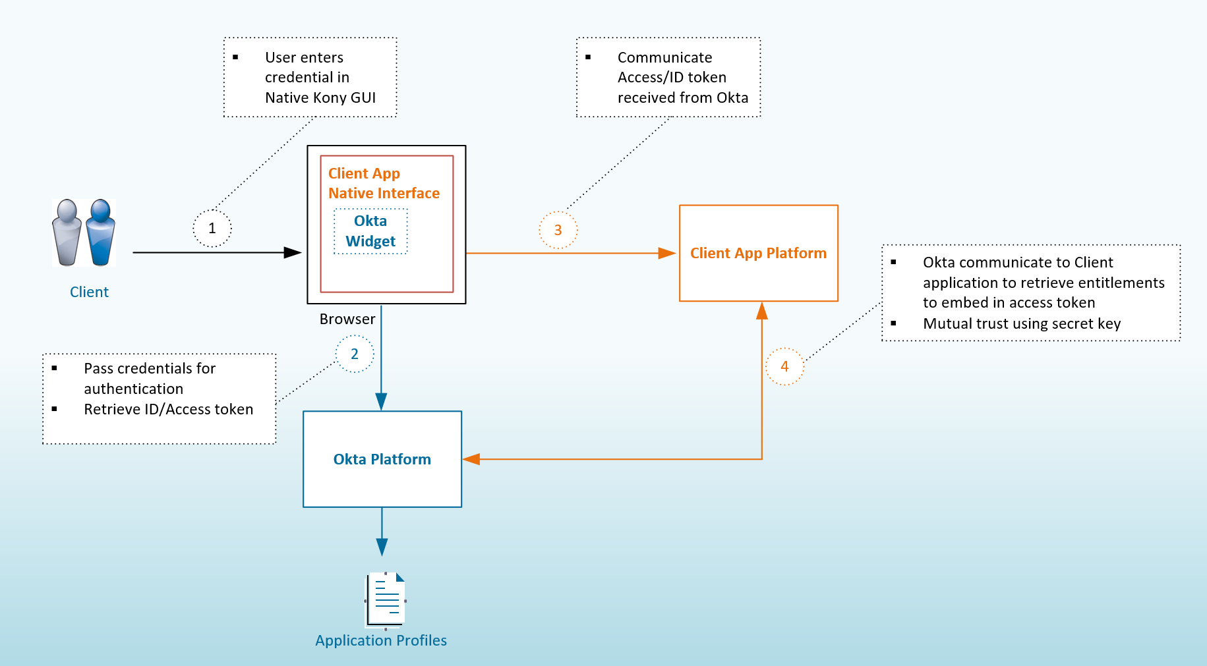

#### Login Flow – OIDC exchange

The Authentication flow for both mobile native and desktop applications is based on the Okta widget utilizing the OIDC protocol. Upon successful authentication, the OIDC protocol returns up to 3 tokens: ID token, Access Token, Refresh Token. The ID Token is utilized by the application to confirm the user is authenticated and includes various claims useful to the Online/Mobile banking solution. These are described in greater detail in the following section Okta Token Usage.

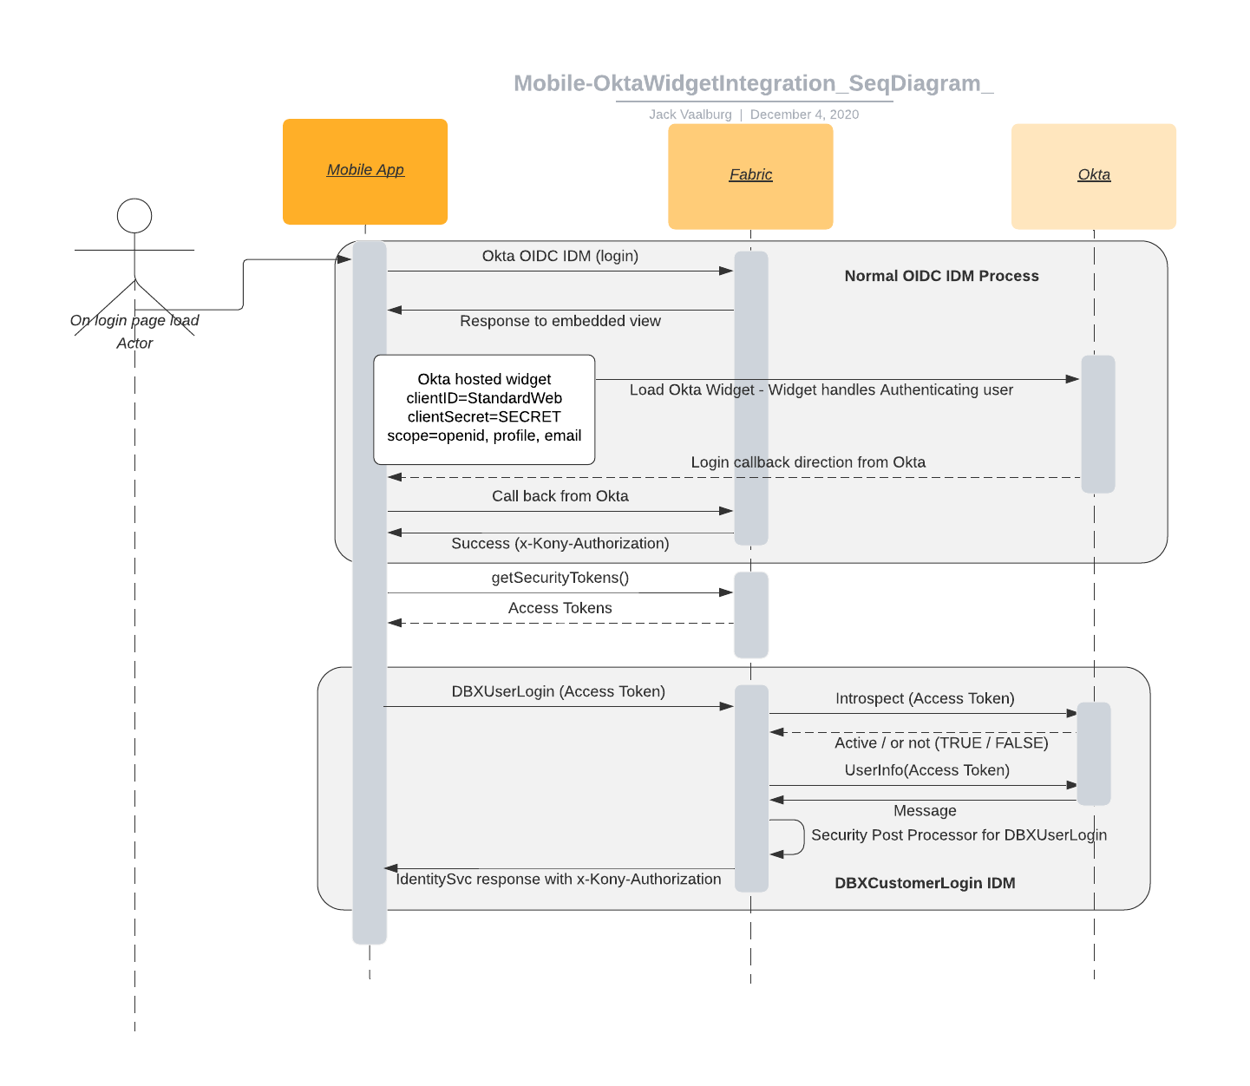

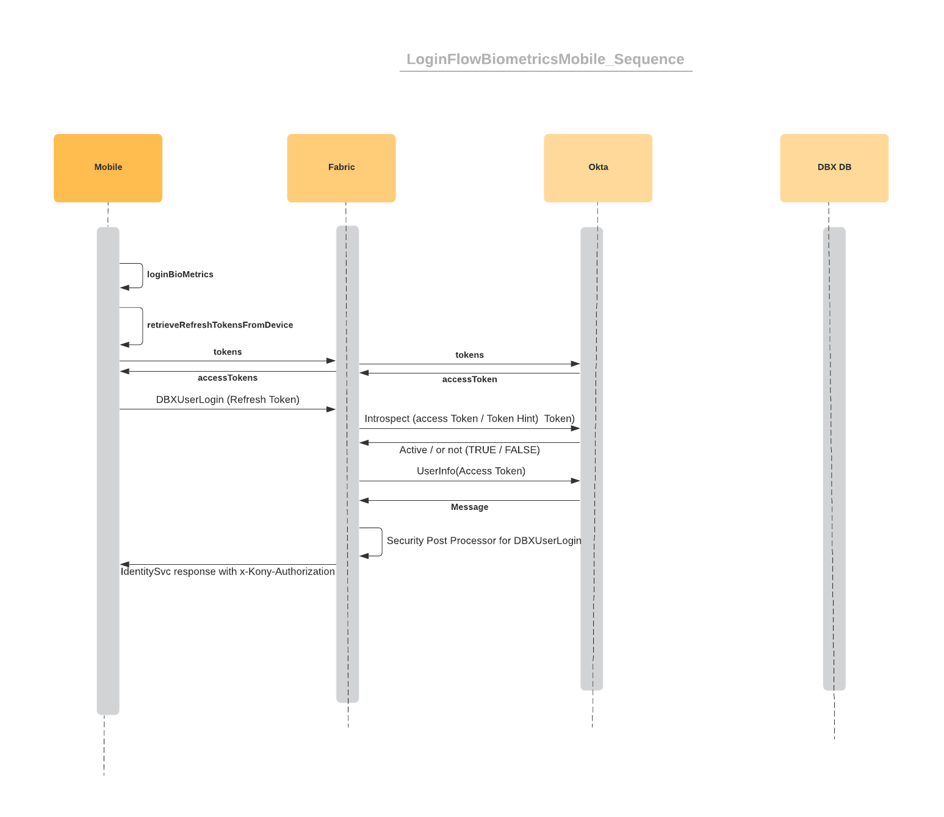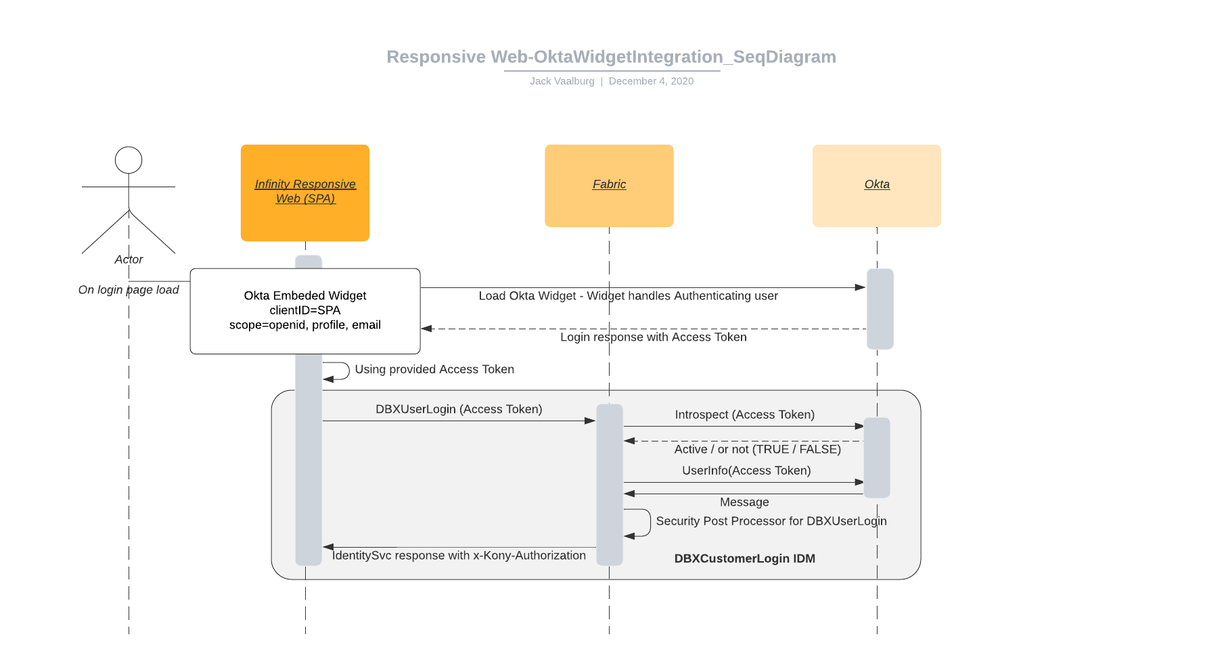

#### Okta Token Usage

**ID Token**

The ID Token is a security token granted by the OpenID Provider (Okta) that contains information about an End-User. This information tells the Infinity application that the user is authenticated, and can also give information like their username or locale.

The ID Token can be passed to different components of the Infinity client, and these components will use the ID Token to confirm that the user is authenticated. The token will be validated against an Okta endpoint. Infinity can also exchange this token for an internal Infinity session token.

The token expiry must be honoured and validated at various points within an Infinity session. Ideally this would be done against Okta to ensure that revoked tokens result in a termination of an Infinity session.

The ID token will include the following attributes:

* Okta Subject ID (immutable)
* Email
* Username
* Personal CIF (not available for delegates setup through Infinity)
* Personal PAN (not available for delegates setup through Infinity)
* First Name
* Last Name

**Access Token**

After authentication the signed access token is issued to the end user and passed to the Infinity application. Infinity will pass this to all CWB APIs hosted on Mule. Mule will utilize this token to enforce CWB security controls. (See API Security). Access tokens should be relatively short-lived and refreshed at frequent intervals. The token must be valid (and not expired) when passed to the CWB API layer. Therefore, Infinity must orchestrate refreshes of this token as required to ensure the token remains active.

The Access token will include the following attributes:

* Okta Subject ID (immutable)
* Email
* Username
* Personal CIF (not available for delegates setup through Infinity)
* Personal PAN (not available for delegates setup through Infinity)
* First Name
* Last Name

**Refresh Token**

A refresh token is a special token that is used to obtain additional access tokens. This will primarily be used in the mobile authentication use case in support of biometric authentication and the Quick Balance functionality. A refresh token is requested alongside the access and/or ID tokens as part of a user's initial authentication and authorization flow. The mobile application will securely store refresh tokens on the mobile device to support biometric authentication and eliminate the need for the user to provide user credentials.

Public clients such as the Infinity browser-based SPA application will not use long-lived refresh tokens because there isn't a way to safely store a persistent refresh token in a browser and assure access by only the intended app.

#### Logout

Infinity will utilize the signOut method available through the Okta AuthJS library. There is a redirect to an Okta hosted page before returning to the application. The logout redirect URI must be configured with the Okta application. This method provides the ability the revoke the access and refresh tokens.

Details to invoke this method call are available at the following link: <https://github.com/okta/okta-auth-js#signout>

#### Password Changes

CWB security policy requires that customer credentials are never in an unencrypted form when traversing from browser to the Customer Identity and Access Management (CIAM) component. To address this requirement, CWB has determined that wherever possible, authentication flows, change password flows and forgotten password flows must leverage the native widget capabilities of Okta. Where this is not possible, CWB can consider the in-browser encryption of passwords, with the decryption centralized on a trusted and CWB managed component (such as Mulesoft).

The preferred flow as described in CWB Change Password Architectural Decision is as follows:

“Infinity will call an Okta API (via Mule) to trigger the forgot password process (see #1 below). Okta will generate a recovery token (valid for 1 hour) which the Infinity application will pass to the Okta widget (see #2 to #5 below). The Okta widget presents the recovery password flow, first presenting a security question and then optionally challenging with other MFA factors (as per Okta policy). On success, the Okta widget will redirect to a landing page within the Infinity application. This also supports the mobile use case, but with the caveat that the widget must be presented in a chrome tab (or safari equivalent).”

**Infinity Deliverables**

* Integrate with an API call into the MuleSoft “Forgot Password” exposed endpoint
* Ability to receive the recovery URL with the recovery token
* Expose a “Reset Password” end user interface element (i.e. button, etc.) to trigger “Forgot Password” flow
* Direct the user to the Okta embedded Widget using the recovery token acquired above to complete the “Forgot Password” flow
* Configure the Infinity application (possibly Fabric) to handle the Okta URL paths for the “Forgot Password“ flow
* Configure the Okta embedded Widget with “routing” enabled to handle the Okta URL paths for the “Forgot Password” flow

**MuleSoft Deliverables (for “Forgot Password” flow)**

* Expose the Okta API for triggering the “Forgot Password” flow

**Techjutsu**

* Support and provide the necessary Okta demos and documentation outlining the “Forgot Password” flow.

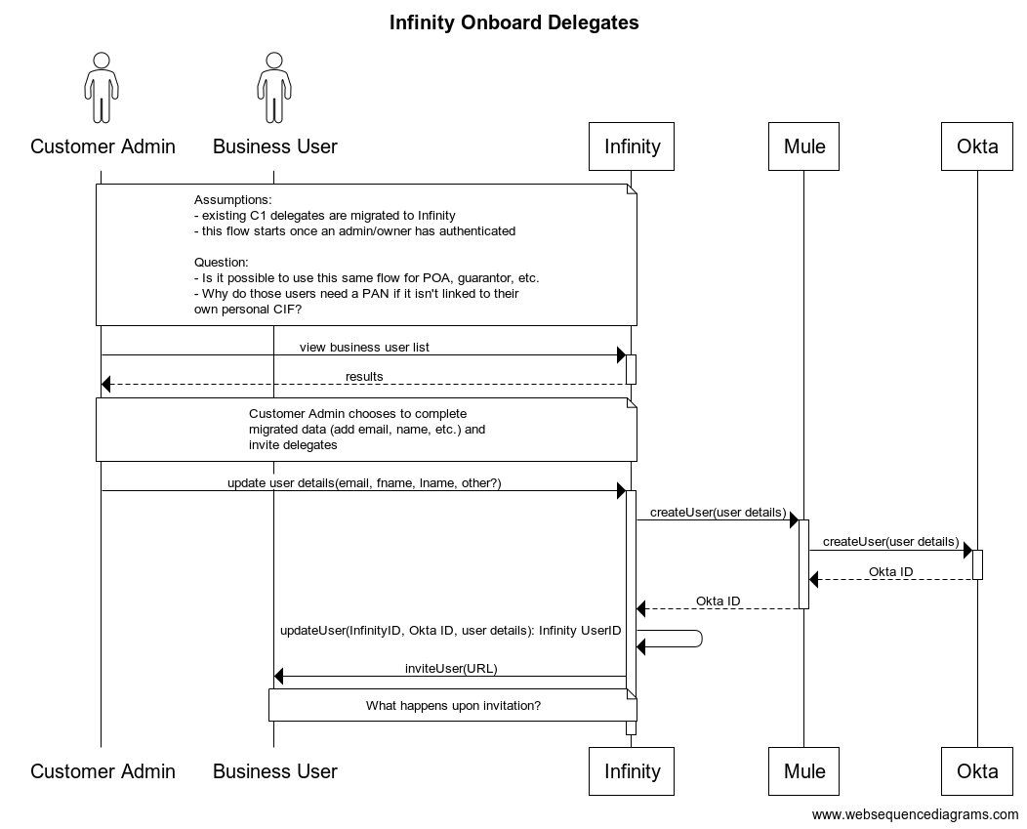

#### Password Strength Enforcement

Okta will enforce password strength rules. DCO will reflect these rules via a regular expression (already provided to them), but final enforcement is through Okta. The change password process is also through the Okta widget and will naturally enforce the password strength rules that time. Okta will apply policy and check against previously used passwords, easily compromised passwords and various other heuristics to ensure our customers are utilizing strong passwords.

#### IAM Policies

Password strength policy, expiry policy and MFA factor policy are all stored and managed directly in Okta. Modifications to these policies are directly taken into account by the Okta widget. This can be modified by an entitled employee and must be managed very carefully since changes to this policy have immediate effect on CWB customers. All changes to Okta must be monitored by the CWB SIEM.

#### Forgot Password

Forgot Password is not currently in MVP scope and will be solved for a subsequent release.

#### Mobile Device Registration & Biometric Authentication

The mobile device registration flow from the Infinity mobile application will be as follows:

* User authenticates using the Okta widget with the application requesting the Okta refresh token
* Upon successful authentication the refresh token will be stored in the Mobile device’s secure credential storage
* Subsequent logins with the mobile device’s native biometric authentication will validate the biometrics and if successful will retrieve the refresh token from the device and request the ID token and Access Token from Okta. No further credential validation (i.e. username/password) will be required. If the refresh token has expred, then the traditional Okta widget login process will be required to re-establish a biometric login. The expiry period for the refresh token must be reasonably long to provide a good user experience, but an expiry of this token is required. The recommended expiry period has been communicated and captured in Okta configuration documentation.
* All subsequent calls to CWB services will utilize the Access Token from Okta.
* The Infinity platform is responsible for determining if the user has registred for biometrics. When biometrics are the users preferred login method, then the Okta widget is not leveraged for login after the first successful login. If the user chooses an alternate login method (i.e. they choose not to use biometrics), then the Okta widget is presented and the Okta login flow is enforced.

#### Quick Balance

Calls for quick balance must use the registered OAuth refresh token on the mobile device to retrieve an access token from Okta. The call for account balances must utilize the access token and cannot be “unauthenticated” as initially proposed by Temenos.

#### Legacy Platform Access Restriction & Legacy Platform Redirection

Central-1 will enable blocking logic to ensure users that have been migrated will not have access to online or mobile banking. The home page should be updated to reflect that some users are being migrated and may no longer have access to the legacy application. When the user is blocked from access Central-1 systems, an informative message will provided directing them to the new online banking application.

Central-1’s solution to this takes into account that the solution is temporary and only required for the transitional period. Once all users have been migrated to Infinity, memberDirect and any temporary solutions will be decommissioned.

Given that Central-1 must provide data for migrated users based on an input file from CWB, Central-1 will store this file locally and cross-reference it for any user authentication. If the username/PAN is in the file, then the user will not be given access to Central-1 systems and appropriate messaging will direct them to the new Infinity platform.

Notes: CWB is awaiting feedback/estimates from C1 (Week of Feb 22 is the expected date)

#### First Login – Overall Flow



#### First Login – Inline Password Hook

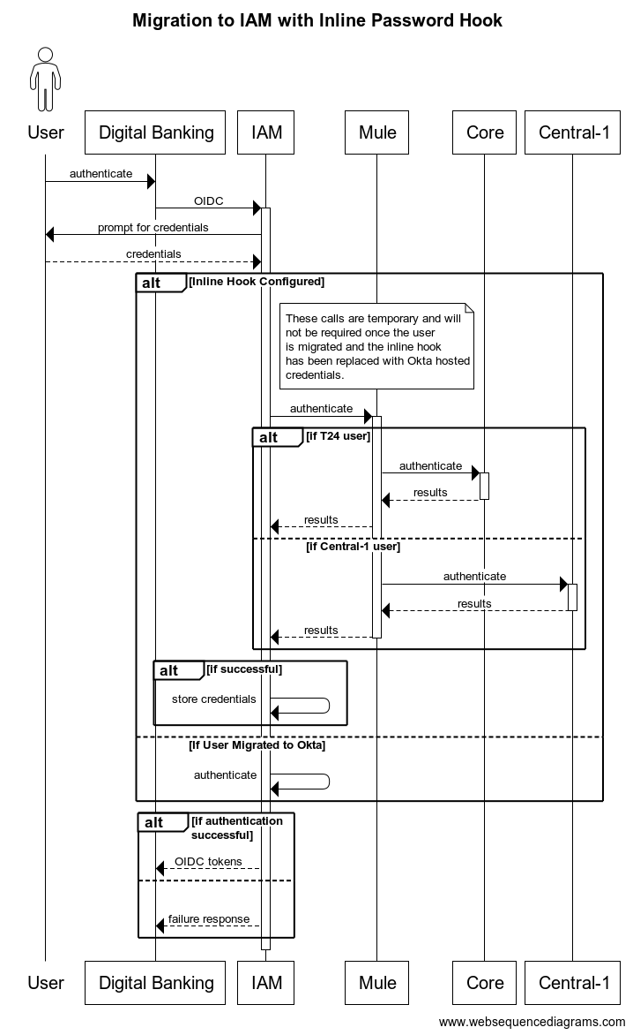

**Sequence Description**

An Okta Inline Password Hook will be configured for users that have been migrated to Okta, but where the user has not yet logged in for the first time. When the user attempts to login, the Inline Password Hook will call a Mule hosted API, and Mule will call either T24 to authenticate users stored in the core, or C1 to authenticate delegates. In the future, the C1 API model can be used for commercial users as well. Upon successful login, the user’s credentials are stored in Okta and the Inline Password Hook is no longer required for that user login.

Mule will determine which API to call based on either the format of the username or by attempting first to authenticate the user against T24 and then against Central-1 if it isn’t successful. This will be determined in detailed design.

#### First Login – MFA Enrollment

The Okta Widget has the responsibility of collecting MFA enrollment. It does this based on Okta’s policy definition. At this time, Okta can specify which factors are available for enrollment and whether they are optional or mandatory. At least one factor must be registered by a user.

The list of MFA factors acceptable to the Digital Banking business and Security will be agreed upon and configured in Okta.

Note: it will be necessary to enable SMS and/or Voice to harden the security around Digital Client Onboarding for delegate users. The details of this are reflected in the detailed DCO process flows. When an MFA factor is pre-configured via DCO, the user will not be prompted to enroll at first login.

#### First Login – Contact Information Update

Some contact information such as email or phone number may not be current in T24. Valid information is essential to support notifications, MFA and recovery flows. It is recommended that Infinity build a screen and logic to present a page to confirm and update contact information at time of login. This is especially true of first login, but should also apply going forward.

The business must determine the logic to apply here, but considerations should be given to collection of this information at pre-defined frequencies to keep the information as up to date as possible.

This information should be updated in the following locations:

* Infinity – to support email and sms notifications
* Okta – to support email notifications
* T24 – to update the personal CIF and improve ongoing communications

#### User Name Selection

The DCO process will incorporate a page that will allow users to specify a preferred username. The username will be validated against Okta, and if it is already registered then the user will be required to enter a different username. It is recommended that defaults be provided by DCO that have a high likelihood of being unique, such as the user’s email address. Ideally Okta would recommend alternatives if the username is already taken; however, this is not a feature Okta supports at this time.

It should also be noted that there is some potential for a malicious user to fish for existing usernames in the Okta system using this method. The user at this time has already gone through an extensive identity verification process, fraud and AML checks. It is highly unlikely this would be utilized at this time to search for existing users in the system.

The username will be set at time the Okta record is created via an API call. These details are found in the onboarding flows below.

#### Factor Sequencing

Okta’s *Factor Sequencing* modifies the sequence of credentials required at login. In a typical application, username and password are first requested and then MFA if necessary. In CWB’s implementation, we have chosen to challenge the user with username and MFA factor first and if successful, the user will be challenged with their password in a final step. If an MFA factor is not yet registered, then user will be challenged with their password first.

#### SSO Capabilities

Integration with Okta’s widget establishes an SSO (Single Sign-On) session, and set the Okta session cookie in the web browser. The SSO session will support various SSO scenarios, including Digital Banking’s integration with DCO, transferring an authenticated state to DCO. This solution will be depicted in the DCO SDD; however, in general it relies on the widget’s ability (or the Okta SDK, depending on how DCO chooses to solve for this problem) to determine if a user has already authenticated. If the user has an Okta session, the the OIDC tokens will be returned to the client application and the user will be able to proceed without being challenged further for credentials.

#### Onboarding new-to-bank personal banking Relationship

The Okta record will be created by the DCO process via an API call facilitated by Mule. No Infinity record will be created at this time. Infinity will create a user record at time of first login with an authenticated Okta user that is authorized to access Online banking. Coarse-grained access to the channel is set in Okta, and without this setting a user will not be able to authenticate against the channel. DCO will collect the user’s password and encrypt it within the browser. This encrypted password is sent to Mule where it is decrypted and stored in Okta, where it is encrypted again as per the Okta configuration.

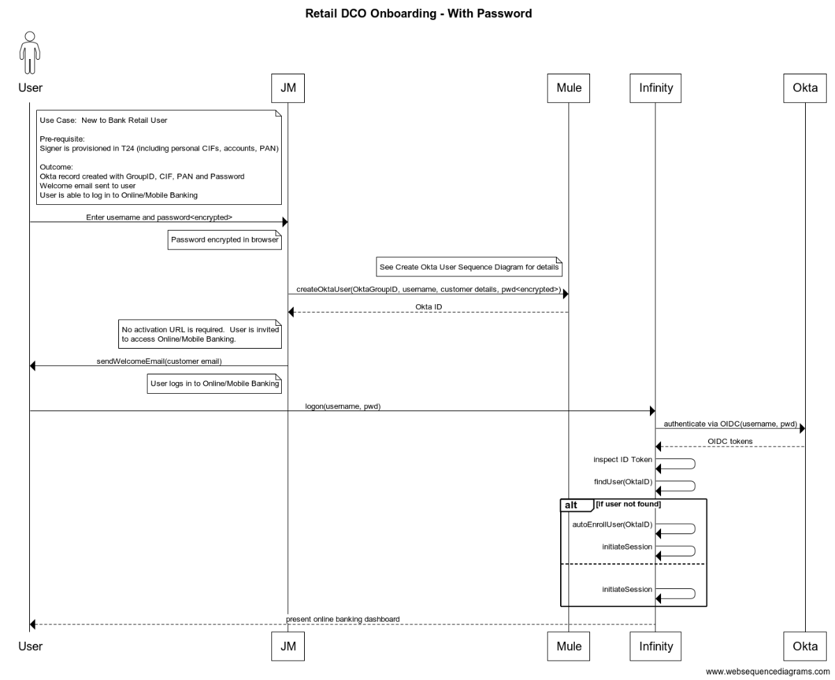

#### Onboarding new-to-bank business banking relationship

The DCO process will work directly with Infinity APIs to create the small business virtual company, cache accounts, create a user and set entitlements. This is an Infinity platform level integration and will not require Mule integration. However, Infinity will also be required to call Okta to create the user record. Infinity will facilitate this call since users can also be added via Spotlight and can take advantage of a common/reusable orchestrator to enable the user’s access through Okta. An activation email will be sent to the user in this case to collect a password and recovery credentials.

The Okta record will be created by the DCO process via an API call facilitated by Mule. No Infinity record will be created at this time. Infinity will create a user record at time of first login with an authenticated Okta user that is authorized to access Online banking. Coarse-grained access to the channel is set in Okta, and without this setting a user will not be able to authenticate against the channel.

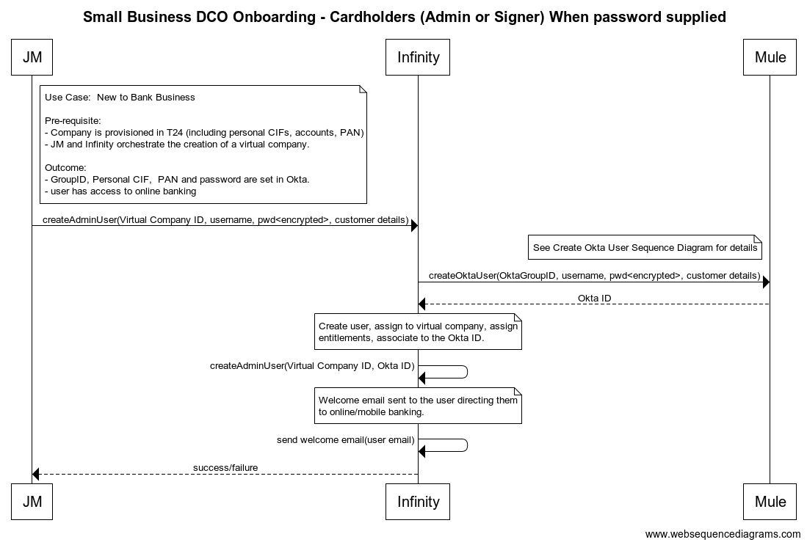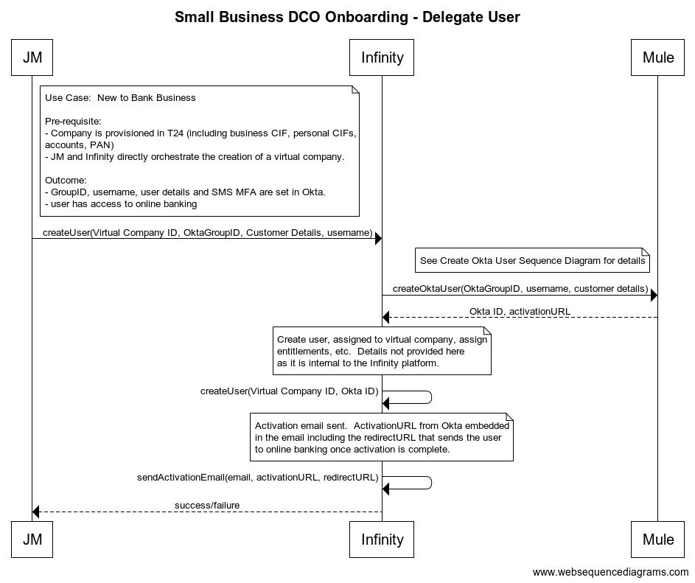

#### Create Okta User – Reusable API

The following flow is reused by all of the Onboarding flows above and will be developed as a reusable API. The API will be called in both DCO and Infinity/Spotlight use cases to create Okta user. It supports users that supply a password and those that are onboarded without a password. In the event a user is onboarded without a password, the mobile phone number will be used to pre-set the SMS MFA factor, ensuring the user must supply this factor when first logging in to Infinity.

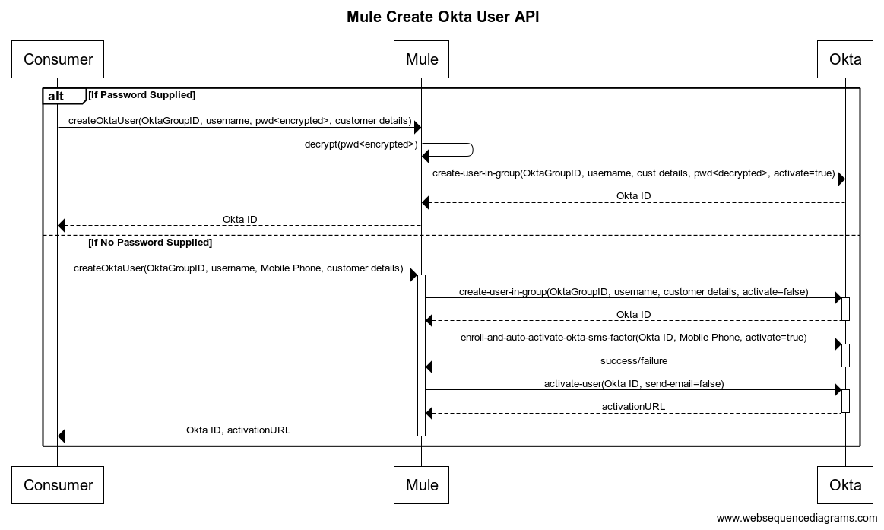

#### Check if Okta user exists – Reusable API

The following flow is reused by all of the Onboarding flows above and Infinity to determine if a username is already taken by a user in Okta.

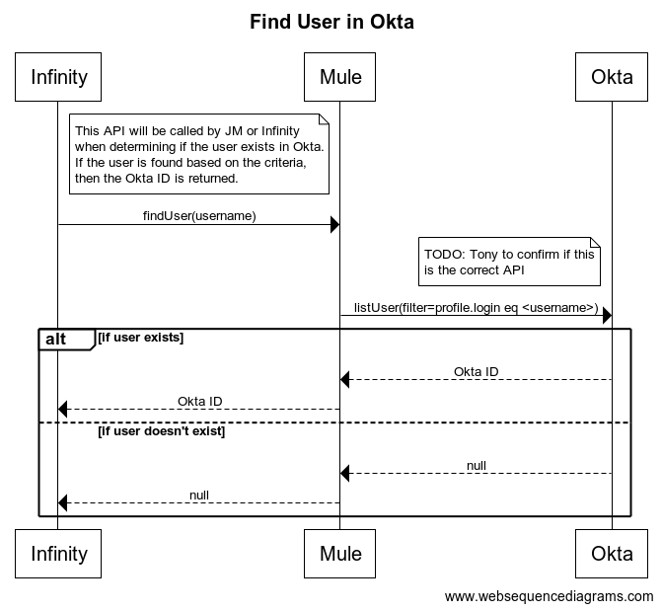

#### Onboarding new business banking relationship for existing client

The DCO process will intiate the authentication process if the applicant self-identifies as having credentials. DCO will integrate the Okta widget and if there isn’t an existing Okta session, then the user will be prompted for credentials. A successful authentication will result in the exchange of OIDC credentials.

The DCO process will utilize the Okta ID provided in the ID token and request additional information from the Infinity platform, to determine if the user is entitled to originate accounts. The personal CIF is directly available from the Okta platform and can be utilized to retrieve additional information about the customer from T24 directly.

Further discussions are required to determine if entitlements need to be taken into account during this authentication process. Ian Hicks is discussing this with the business. Sequence diagram has been started by the Avoka/Temenos Solution Architect, but it is incomplete at this time.

#### Entitlements (Small Business)

Fine-grained entitlements are the responsibility of the Infinity platform and are set at time of digital client onboarding or via the Spotlight administration application. Small business administrators can also set entitlements for their users. Entitlements govern functionality, accounts, limits and approval workflows.

#### New Client Entitlements (Small Business)

Depending on the role the user will play in the small business, DCO will onboard users directly via an Infinity API, providing a role the user should be onboarded with. This will set basic entitlements that will allow the user to access the channel and initiate functions with accounts they are entitled to utilize. Fine-grained entitlements selections will NOT be made via DCO, therefore, the business must identify 2 general “roles” that include the application/signer and delegates. Beyond this, entitlements should be configured via Infinity.

#### Consolidated Business Accounts

Business accounts are consolidated utilize the Virtual Company construct of Infinity. Any number of business CIFS can be consolidated under this construct and access is given to each user based on their entitlements. PANs will not be stored, but they are derived based on a user’s CIF and the CIF of the business they have access to.

The Virtual Company construct is company based and is therefore very different from what is done with small business today. This is much more aligned to a commercial banking setting. Further work is required to understand how data is migrated into this model.

#### Consolidated Retail Accounts

A retail users’ Okta record will hold the personal CIF and PAN. This PAN is utilized to retrieve the available accounts for a retail user. If a user is consolidated with a retail account and a virtual company (in Infinity), then Infinity will read the PAN from the Okta record to retrieve the retail accounts and will utilize the virtual company construct to retrieve the business accounts for a particular user. Only one retail account can be consolidated and that is enforced by the fact that Okta will only hold a single retail PAN.

### Transaction History

The Temenos Infinity Digital Banking platform shifts some of the transaction history search responsibilities from the Digital Banking platform to the systems of record. This leaves CWB with a decision to make on where this functionality should be implemented to meet the functional and non-functional requirements of the online and mobile banking experiences.

Currently, CWB T24 offers a basic transaction search capability based solely on a date range. Central-1 uses this service, to request all transactions within a date range and then filters the result set with the additional search criteria provided by the user. This can include filtering by transaction type, amount, cheque number and confirmation number. Presentation layer paging is supported by Central-1 directly. Annecdotal evidence suggests this doesn’t scale well for business customers that generate significant numbers of transactions within a day, and intuitively means that in many cases more transctions are pulled from T24 and transmitted to the digital banking layer than are required for presentation purposes.

Search criteria for the future state online and mobile banking includes date range, keyword, transaction type, cheque # range from/to, and amount range from/to. The desired state for commercial customers is to permit this search criteria against 1 or more accounts at one time.

Customers with CWB credit cards currently access all of the credit card data through Collabria MyCardInfo application. In the future a new retail card provider (BRIM) will also provide access to transaction history through the BRIM portal. Target online banking capabilities will embed much of this functionalty directly in the Digital Banking Platform, but with search capabilities restricted to those directly supported by the credit card vendor via their APIs.

**Solution alternatives assessed:**

* Alternative 1: Enhance T24 Search Criteria & Cache Results For Paging
* Alternative 2: Existing T24 Search Criteria & Infinity Caches Results for Search and Paging
* Alternative 3: Existing T24 Search Criteria, Mule Applies Search Criteria, Cache Results for Paging
* Alternative 4: Synchronize T24 Transaction History with Temenos Datalake, Temenos Datalake Applies Search Criteria, Cache Results for Paging
* Alternative 5: Synchronize T24 Transaction History with Temenos Datalake into Infinity Digital Banking, Digital Banking Searches local database
* Alternative 6: Existing T24 Search Criteria, Batch Synched Operational Datastore, Mule Hybrid Search & Cache for Paging

The recommended architecture involves a tactical approach and a strategic approach. The architecture initially adopts existing building blocks, with incremental adoption of new building blocks that improve the performance and capabilities of the transaction search capability to meet the final requirements of the commercial banking channel.

#### Short Term (Anticipated Timeframe: Small Business and Retail Banking)

To get the project development started, the project will adopt **Alternative 3: Existing T24 Search Criteria, Mule Applies Search Criteria & Cache for Paging**.

In this solution, Digital Banking calls Mule, Mule calls T24 and repeats this as necessary to collect the full set of data from T24 (based on date range only), Mule applies the search criteria to the data collected in memory before returning the results to Infinity. Mule will utilize its caching capability to support backward/forward “paging”.

This alternative does not introduce any changes to Infinity, T24 or any other downstream system, and offers reasonable performance for parties (retail or business) with average transaction history datasets. This solution should be equivalent to the performance offered by Central-1 today. Once in place, CWB will test various customer data sets, confirming if/when the solution exceeds the desired performance targets. The results will determine when CWB will need to transition to the next phase(s) of the architecture.

There is no dependence on the Temenos Datalake architecture.

#### Long Term (Anticipated Timeframe: Commercial)

Fully leverage the Datalake architecture and implement **Alternative 4: Synchronize T24 Transaction History with Temenos Datalake, Temenos Datalake Applies Search Criteria, Cache Results for Paging**.

The Temenos Datalake is licenced by CWB and intended to support both operational, staging and analytical data stores. Temenos has devised an architecture that will allow T24 data changes to be published to the Datalake in near real-time or batch processes. Near real-time replication depends on the implementation of this capability to support the replication of transaction history data and any necessary meta-data to support the calculation of running balances.

Once this near real-time feed is in place, the Temenos Datalake can become the source of truth for transaction history. The Temenos Datalake will expose transaction history via an API and offer the full search criteria required by Infinity Digital Banking. Note: A patch is required to T24 to support the near real-time replication of transaction history and any supporting tables required to offload the transaction history search capabilities.

Infinity Digital Banking will send all queries via a Mule hosted API and Mule will call the Temenos Datalake API to execute the query and return the results. Infinity Digital Banking or Mule will store the results in a cache to support paging functionality; however, a backward paging capability can be supported by Temenos Datalake as well.

When transitioning from the small business/retail solution, Mulesoft search capabilities can be eliminated in this case, offloading the search and paging to the Datalake operational datastore. This will provide the best scalability and allows for future complex queries, including optimized searches across multiple accounts in a single query statement, full text searching and businesses that generate large transaction volumes.

It is not anticipated that credit card transactions will be held in this repository. Access to credit card transactions is limited to the use of the credit card vendor’s API.

### Alerting

The Digital Banking project has introduced a number of alerting requirements beyond what was provided by Central-1’s online banking platform. The new alerting requirements introduce a wide variety of security and transactional alerts. These must be triggered regardless of the channel originating the security or transactional event, and delivered via SMS, email, push notifications and secure messaging.

An architectural decision was created and approved on the target alerting solution. The solution will require systems such as Okta and T24 that are aware of events of interest to Digital Banking to send these events to Infinity (via Mule), where the events will be checked against subscription information and then delivered to the customer via the channels they have chosen.

#### R1 Detailed Scope and Solution

Due to the time constraints of the MVP release, both scope and solution are impacted. The following table lists the alert types supported during the MVP phase and how they will be solved. Users will not be required to subscribe to security events. Okta will be configured at a tenant level to send alerts for all users and will utilize the registered email address to do so.

Customers may also have external access to credit card portals. These events are managed and sent directly by the credit card provider.

|  |  |  |  |  |  |
| --- | --- | --- | --- | --- | --- |
| Alert Type | Alert Function | Retail | Small Business | R1 | R1 Solution |
| Security Alert | New payee added | Y | Y | Y | Infinity will trigger these for R1 and transition to the T24 alerting module when it becomes available. |
| Security Alert | Online login | Y | Y | Y | Okta to send New Device Email with Suspicious Activity button. |
| Security Alert | Password Changed | Y | Y | Y | Okta to send password change notification via email with Suspicious Activity button. |
| Security Alert | Online banking account locked - incorrect Password | Y | Y | Y | Okta to send account locked notification via email with Suspicious Activity button. Self-service unlock is supported. |
| Security Alert | Online banking account locked - incorrect response to MFA | Y | Y | Y | Okta to send account locked notification via email with Suspicious Activity button. Self-service unlock is supported. |
| Security Alert | MFA Enrollment | Y | Y | Y | Recommended by Architecture/Security office.  Okta to send email. These emails are sent to users who enroll in a new 2nd factor for their account and can have the opportunity to report suspicious activity from the link provided in the email. |
| Security Alert | MFA Reset | Y | Y | Y | Recommended by Architecture/Security office.  Okta to send email. These emails are sent to users when a 2nd factor for their account has been reset and can have the opportunity to report suspicious activity from the link provided in the email. |
| Balance and Activity Alert | Interac e-transfer recipient added | Y | Y | Y | Infinity to trigger the sending of an alert. No other CWB system is able to add or maintain recipients since they are held directly by Interac. |
| Small Business Alert | Transaction pending approval | N | Y | Y | Infinity to trigger the sending of an alert. |
| Small Business Alert | Transaction about to expire | N | Y | Y | Infinity to trigger the sending of an alert. |

TODO: standardize table formatting

#### Solution Diagram



#### Future Release - Integration Pattern

Future releases of the alerting solution will require systems of record (such as T24) to capture and send events to the Infinity Alerting Engine. T24 has an alerting module that is currently not used by CWB, but will be enabled and configured for all account related events including changes to account balances, withdrawal and deposit events, account overdrawn, loan payment reminders, etc. This will be elaborated on further for future releases, but the general pattern for integration is shown below.

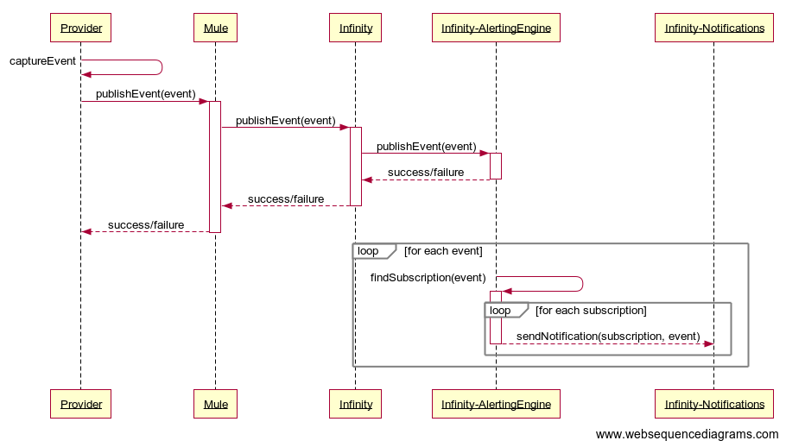

### SMS Provider

In CWB’s current online and mobile banking solutions, SMS notifications are orchestrated by Central-1 and delivered directly without CWB intervention. With the new Digital Banking platform, SMS notifications will be triggered by CWB systems and delivered through a 3rd party communications provider. During the Digital Client Onboarding stream an SMS provider was selected for relatively low-volume notifications. Our DCO provider (Temenos/Avoka) supported an out of the box integration with AWS SNS which CWB adopted due to project timelines.

Generally speaking, our technology partners are pre-integrated with several common communications providers. CWB’s own research has identified leaders as highlighted by various recent publications, including IDC MarketScape Worldwide Cloud Communications Platforms (Sept 2019) and Gartner’s Market Guide for Communications Platform as a Service (Aug 13, 2019).

**Communications Provider Selected**

Twilio is the market leader for CPaaS, opening up options to CWB for use cases that go behond basic SMS and involve more complex voice or video scenarios. Their pricing is reasonably competitive with some opportunity to negotiate better rates with committed volumes. Twilio has indicated they have no limitations delivering to any Canadian carrier, which sets them apart from Vonage and Clickatell where some carrier constraints were identified.

**Integration Pattern**

Infinity supports a pre-existing integration with Twilio. Changes to this integration approach would result in significant customization of the Infinity application. Direct integration from Infinity to Twilio is supported for the following reasons:

* Fastest to Market
* OOTB Infinity Engagement server capabilities immediately available
* Knowledge gained through the configuration of the SMS Provider is transferable to other projects with SMS, voice or marketing needs.
* Indirect integration through Mule can be enabled for other applications as required
* Temenos has the most experience integrating with Twilio which should lead to a more seamless integration. Any other option would add approximately 1 month to the project.

**Type of Number for SMS Delivery**

Note: CWB Legal should confirm the recommended number complies with with the intended use case(s).

**Medium/Long Term**

Short Code – It can take 6-12 weeks to go through the application process and lease a short code. As user adoption increases, it will be beneficial to leverage a short code to ensure CWB is not subject to carrier filtering. Alerts through short codes have the greatest potential for timely delivery which is important for the alerts our customers are subscribing to. Short Codes should also reduce CWB operational overhead when solving for undelivered message scenarios.

**Short Term**

Toll Free Number – Toll Free Numbers can be acquired immediately without any delay for implementation/testing and is projected to scale with continued compliance to Canadian regulations as alerting adoption/volume increases.

As per SMS provider documentation, the alerting use case and the calculated messaging volumes are acceptable for Toll Free Number delivery. However, it should be noted that toll free numbers are treated the same as long code numbers in Canada and are subject to carrier filtering. It is for this reason the communications providers generally recommend Short Codes.

Multiple numbers should be purchased to ensure the SMS Provider does not queue messages in the event a relatively large number of messages need to be sent at one time. Queued messages may not be delivered in a timely manner when received in batches since each number is limited to 1 MPS when sending out to carriers to ensure the potential for carrier filtering is minimized.

Sticky Sendor (or Pesistent Sender ID) should be enabled by the SMS Provider to ensure the same number is always used to send messages to a specific customer phone number. This helps build customer trust in the communications triggered by CWB.

Note: This option may be required in all cases to ensure CWB can deliver messages to non-Canadian carriers since short codes are country specific.

### Email Provider

Infinity will send all email transmissions via the CWB Proof Point SMTP Relay. All communication will be secured via TLS (SMTPS). Detailed configurations will be provided by the I/O team at time of implementation.

### Product Level Entitlements

The Digital Banking platform is dependent on CWB account summary message to indicate how a certain account may be used in the context of digital banking. For example, can the underlying product be used in a bill payment scenario, or to transfer funds in/out. In most cases this is already supported by the ISO messaging. Where it isn’t, Mule will add this information in to the message response. The ideal solution here would be that the Digital banking platform has a table where it can lookup each product and determine how it can be used in the context of digital banking. Architecture will pursue this approach with Temenos for future iterations of the product.

### CRA Direct Deposit - Draft

Using direct deposit, the Government of Canada can deposit payments automatically in customers’s accounts (personal, small business or business). For a customers to receive automated payments automatically through direct deposit they need to first sign up. Upon customers signing up for direct deposit, CWB’s system collects information as shown below in the paragraph *Capture Direct Deposit Information* then create a file with all pending requests and sends to CRA over SFTP as shown in paragraph *Send Direct Deposit to CRA.*

#### Workflows

#### Capture Direct Deposit Information



#### Send Direct Deposit to CRA



#### Data Elements

* + - * 1. Retail Baning Data Elements

|  |  |  |  |  |  |
| --- | --- | --- | --- | --- | --- |
| Element Name | Description (EN) | Length | Format | Accepted Values | Comments |
| FileCreateDate | DateTime when data was created | 19 | yyyy-mm-ddThh:mm:ss |  | 2020-03-01T11:43:09 (to match the sample xml file) |
| RecSeqNbr | Record sequence number | 10 | numeric |  | This field will be a unique row number starting at 1 that would sequentially increase by 1 for each additional row of   data in the file.  The last record sequence number will match the “total record count” element. |
| RegistrationEdt | Effective date of the registration | 10 | yyyy-mm-dd |  |  |
| SIN | Social Insurance Number (SIN) | 9 | numeric |  |  |
| Surname | Surname | 30 | character |  |  |
| GivenName | Given Name | 30 | character |  |  |
| BirthDate | Date of Birth | 10 | yyyy-mm-dd |  |  |
| Branch | Bank Branch Number | 5 | numeric |  |  |
| Institution | Bank Institution Number | 3 | numeric |  | There is a mistake on the sample xml file being stated as 4 numeric |
| AccountNumber | Bank Account | 12 | numeric |  | This field should contain the actual bank account number with no leading zeroes.  (if the bank account number is 7   digits in length, please only populate this field with those 7 digits) |
| Channel | The bank's channel used during registration | 2 | alpha | 01 - ONLINE  02 - MOBILE APP  03 - TELLER  04 - ATM |  |
| TotalRecCnt | Total number of registrations in the file | 10 | numeric |  |  |

Data Samples



* + - * 1. Business Banking Data Elements

|  |  |  |  |  |  |
| --- | --- | --- | --- | --- | --- |
| **Element Name** | **Description (EN)** | **Length** | **Format** | **Accepted Values** | **Comments** |
|  |  |  |  |  |  |
| FileCreateDate | Date and time when data was created | 19 | yyyy-mm-ddThh:mm:ss |  | **Mandatory** |
| RecSeqNbr | Record sequence number | 10 | Numeric |  | **Mandatory**  This field will be a unique row number starting at 1 that would sequentially increase by 1 for each additional row of   data in the file. The last record sequence number will match the “total record count” element. |
| RegistrationEdt | Date of DD registration request by the client | 10 | yyyy-mm-dd |  | **Mandatory**  This is the same as the field used in the DD update process for individuals for CERB. |
| BN15 | The BN15 or program account the client is attempting to update with DD | 15 | Alpha numeric |  | **Mandatory**  The BN 15 would be comprised of a nine digit # followed by 2 alpha characters followed by 4 numeric  E.g. 123456789RP0001  The CEWS payment is being made to the RP account.  The CERS payment is being made to the ZA account  Possible Accounts types include RP (payroll), RC (Corporate Tax), RT(GST), ZA(CERS)  *This can be free-form/auto populated/dropdown/radio box etc. However, please always pass us the BN15 in its entirety regardless of how you choose to implement it. |
| LegalName | This would be the legal name of the entity on record with the FI | 1-80 | Alpha numeric, and some special characters |  | **Mandatory and Auto-populated**  This field is also referred to as the “Business Name”  We understand that not all FIs will have the legal name, an operating or trading name is also acceptable. (i.e. Please auto-populate this field with whatever name you have on file).  **Note:** We will read the first 80 characters provided in the XML entry for the legal name, including any XML script and tags provided before the legal name.  Everything after the first 80 characters will be truncated and not read.  *\*See appendix A for more details.* |
| SIN | Social Insurance Number (SIN) of the owner or partner of a business | 9 | Numeric |  | **Optional** |
| Surname | Surname of the owner, director, partner, or corporate officer of a business | 30 | Character |  | **Optional and Free-form** |
| GivenName | Given Name of owner, director, partner, or corporate officer of a business | 30 | Character |  | **Optional and Free-form** |
| BirthDate | Date of Birth of owner or partner of a business | 10 | yyyy-mm-dd |  | **Optional** |
| DelSurname | Surname of the person performing the transaction. | 30 | Character |  | **Mandatory and Free-form**  Referred to as the “Representative” in the Terms of Use.  Also referred to as the “username/userid” |
| DelGiven | Given Name of the person performing the transaction. | 30 | Character |  | **Mandatory and Freeform**  Referred to as the “Representative” in the Terms of Use.  Also referred to as the “username/userid” |
| Branch | Bank Branch Number | 5 | Numeric |  | **Mandatory** |
| Institution | Bank Institution Number | 3 | Numeric |  | **Mandatory** |
| AccountNumber | Bank Account | 12 | Numeric |  | **Mandatory**  This field should contain the actual bank account number with no leading zeroes.  (if the bank account number is 7   digits in length, please only populate this field with those 7 digits) |
| Channel | The bank’s channel used during registration | 2 | Alpha | 01 – ONLINE  06 – PERSONAL CONTACT | **Mandatory**  We would only accept 01 online and 06 personal contact registrations for BN DD enrollment |
| TotalRecCnt | Total number of registrations in the file | 10 | Numeric |  | **Mandatory** |

#### Data Samples

 

#### File Transfer Frequency

Files must be sent from financial institutions to CRA on a nightly basis, Monday to Friday, including federal/provincial holidays by 11PM (EST) – *refer to schedule below*. Transmissions can be submitted before this time, but any files sent after the cut-off time will be processed the following business day. In case more than one file is transmitted in a day, only the last transmitted file that day will be uploaded. If there are days where no clients register/sign-up for this service, a blank file must be sent to the CRA.

**Schedule (Monday to Friday by 11PM EST):**

|  |  |
| --- | --- |
| 23:00 – 23:29 | CRA processes direct deposit enrolments for businesses via FIs and updates CRA database. |
| 23:30 – 23:59 | CRA runs other unrelated batch processes and updates involving this CRA database. |
| 00:01 - 01:59 | CRA runs validation process and prepares file for CEWS run. |
| 02:00 | CEWS/CERS payments process starts with direct deposit on CRA database. |

#### CRA Connectivity

* + - * 1. Test Environment

|  |  |
| --- | --- |
| SFTP server IP Address | sftp-t.cra-arc.gc.ca |
| SFTP server Port | 2323 |
| Directory for SFTP PUT | /uaclient2cra |

* + - * 1. Production Environment

|  |  |
| --- | --- |
| SFTP server IP Address | sftp.cra-arc.gc.ca |
| SFTP server Port | 2323 |
| Directory for SFTP PUT | /client2cra |

### Bill Payment

Following new functionalities will be addressed as part of this GAP development

* Maintaining Member Vendors in T24 Instead of Central1
* Maintaining Future Dated Bill Payments in T24 instead of Central1
* Multiple Bill Payments in single screen

#### Add Payee

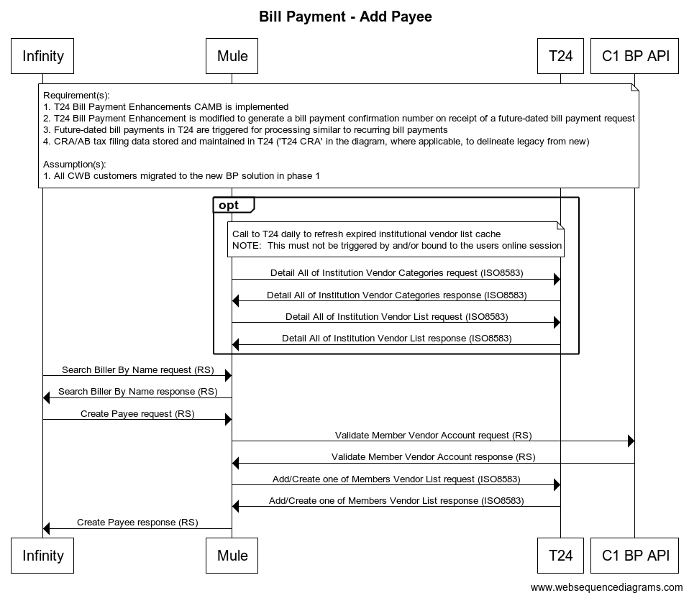

#### Get Payees

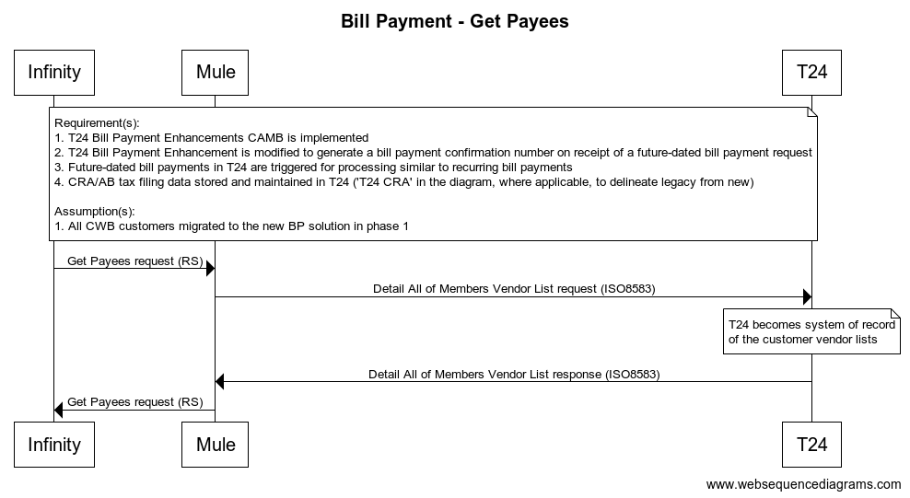

#### Remove Payee

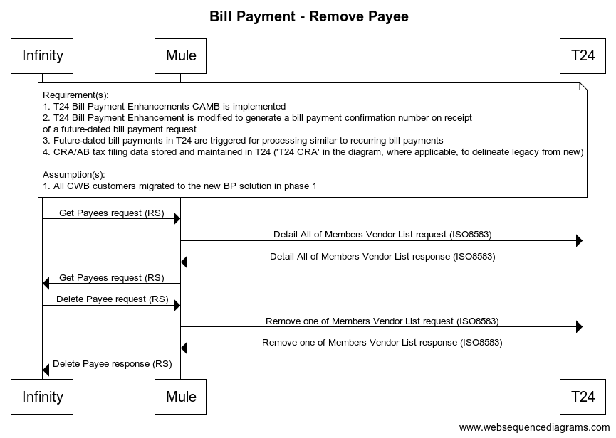

#### Recurring Add/Create Payment

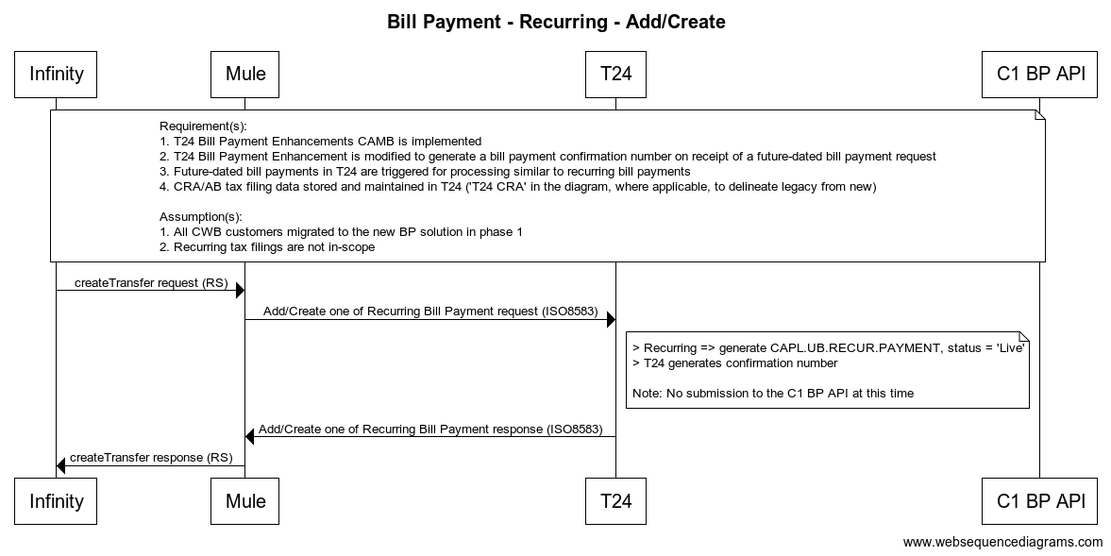

#### Reverse Immediate Bill Payemnts

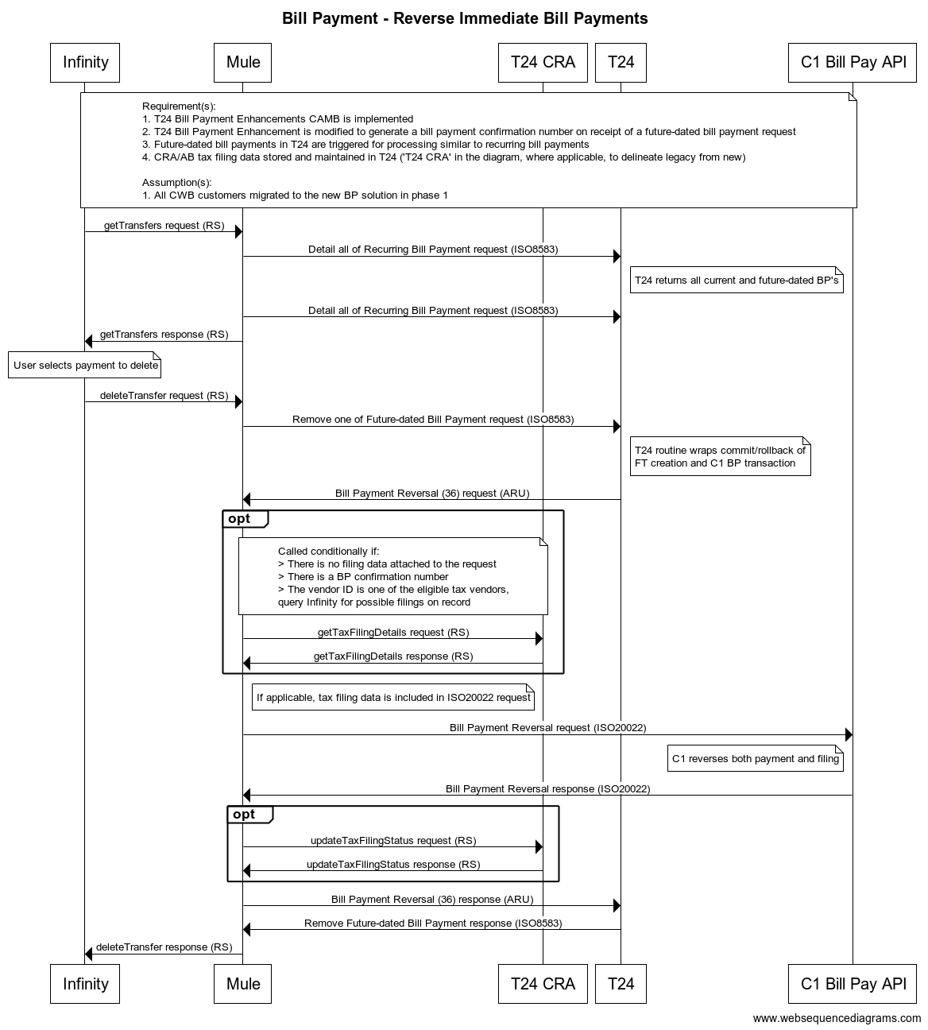

#### Future Dated Bill Payment Add/Create

0.2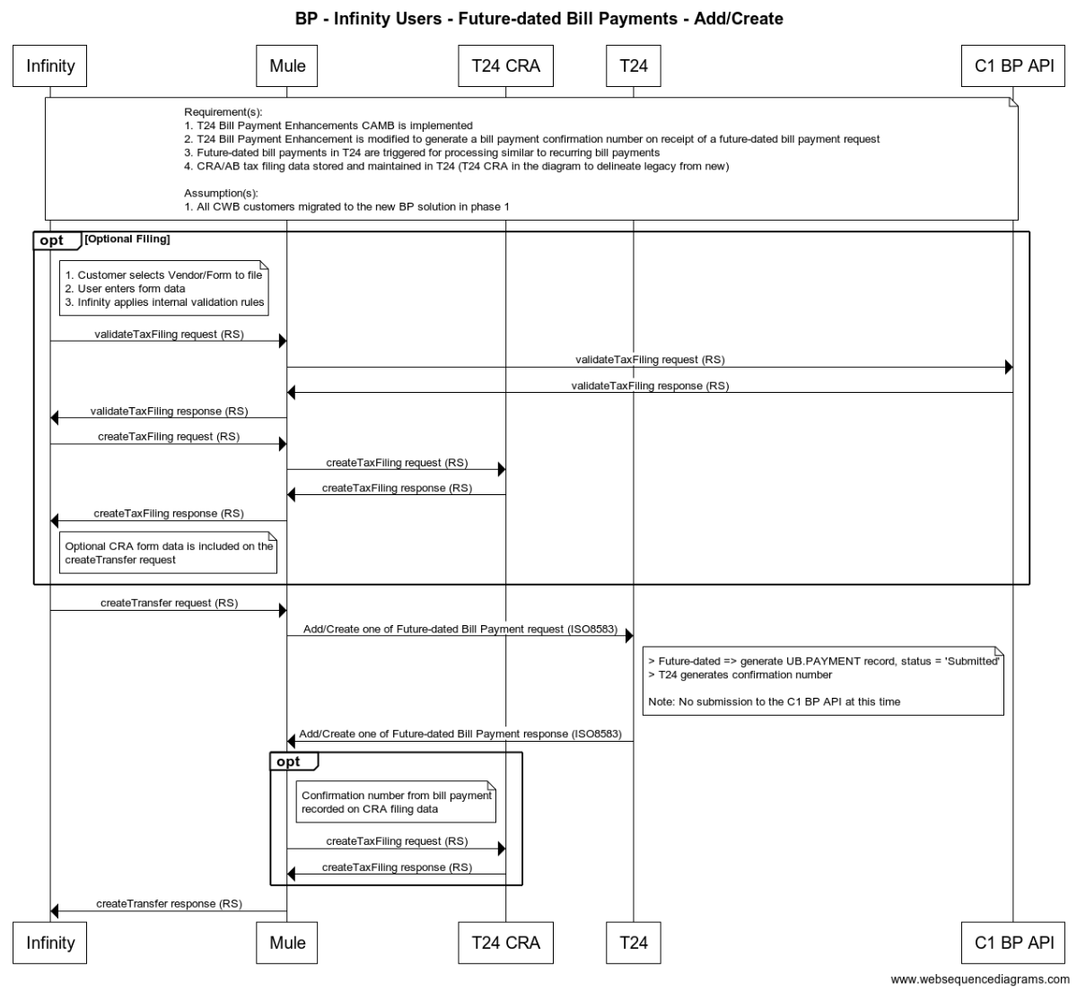

### CRA Tax Payments

TODO (George/Brian):

* The CRA Billers returned from C1 needs to be post-filtered in Mule to ensure only billers registered in T24 are returned to Infinity. Mule has these master billers in cache, so it shouldn’t be a big deal to do this. We agreed to do this Feb 9th. This has not been discussed with the BIG team.
* Clarification on where mapping from Infinity form capture to ISO20022 needs to be identified. How do we ensure the dynamic nature of capturing forms, form data, etc. is not limited by this mapping step? Brian has a good handle on this and C1 is working towards an ISO messaging API that should be able to take the dynamic input fields as input.
* Summary of how we ensure C1 – CRA processing will continue to work with the stated changes. Brian has a good handle on this and also has some sequence diagrams to share.
* Message Changes (High Level), including ARU. Should capture how we are using this legacy messaging with some of our new data fields. Brian has a good handle on this.
* Future Dated One-Time – CRA Filings
  + - Non-migrated individuals – future dated scheduling must be migrated. However, the form data remains at C1. When future dated event is triggered by T24, C1 correlates this to the form data using the trace number. Brian has a sequence diagram to share. Let’s capture it in the SDD.
    - Migrated individuals – future dated scheduling and form data must be migrated to t24.
* Migration?
  + - Any other implications?
      * C1’s view – up to a year out are already scheduled
      * T24 – migration templates to be built in T24
      * Infinity – do we need to migrate the previous forms the customer has posted in the past? This functionality differs from what we do at C1 today. Take billers they have previously paid for and show all forms (and the user can remove as required). Or … don’t prefill and have the customer start from scratch.
* CRA Payment History
  + - C1 is providing the history of form filings via an API – document in SDD.
    - C1 needs to migrate history for this history API to work. This is internal work for C1. Not captured in any SOW yet but will be added.

#### Get/Add Tax Payee

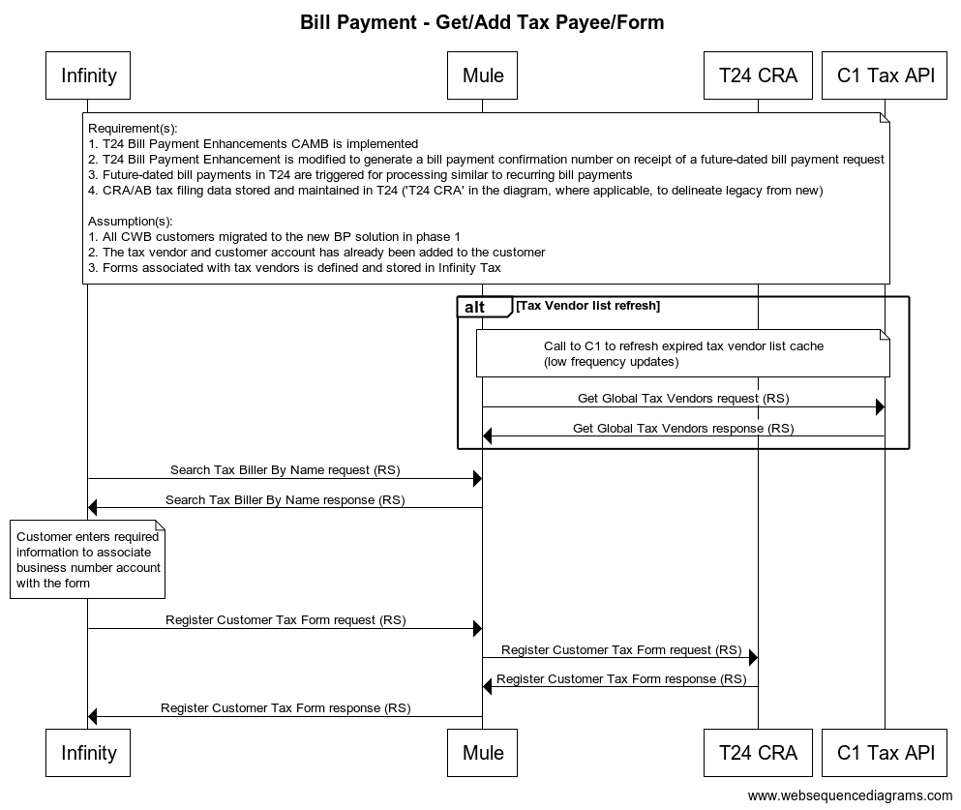

#### Immediate Tax Filling with Payments

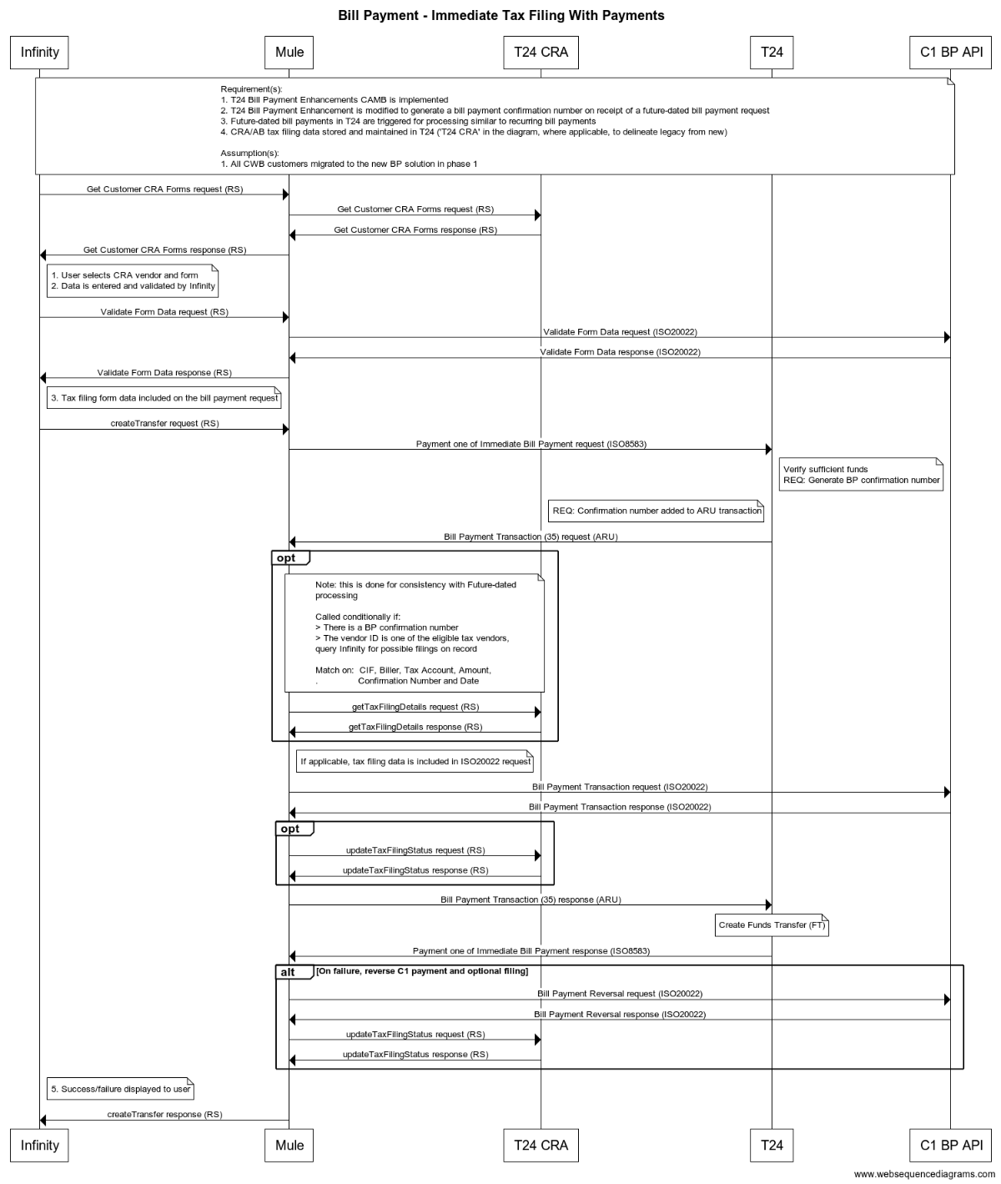

#### Recurring/Future Dated Nightly Batch Payment

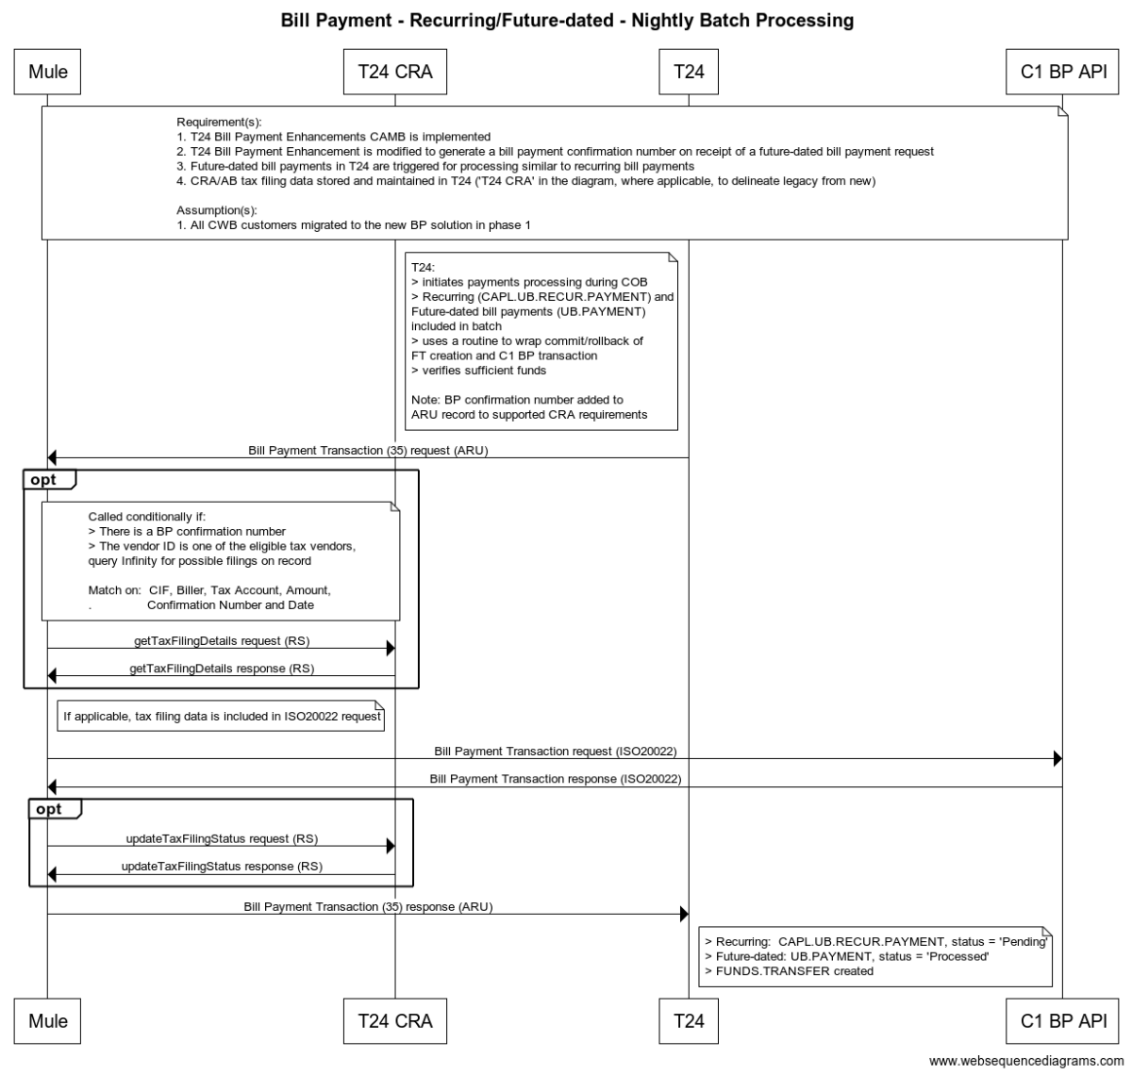

### Mobile Remote Deposit Capture

Mobile Remote Deposit Capture is a feature supported by the Infinity Digital Banking solution. The method supported to capture cheque images is via a native mobile camera integration. In today’s solution with Central-1, users are accustomed to advanced feedback and optimized image handling that ensures the highest quality image is captured and transmitted to Central-1 for processing.

To enhance the capabilities of the Digital Banking platform, the architecture team has identified a mobile SDK from Kofax. The Mobile SDK includes both image capture and image processing capabilities to integrate with applications designed to run on Android and iOS mobile devices. The image capture features improve the quality of captured images, such as stability delay, camera orientation, flash support, and image frame guidelines. The image processing features provide access to a patented processing technology that includes capabilities specific to images obtained from mobile device cameras.

The Kofax solution is a client-side only solution and does NOT require integration with Kofax servers. Once the image is captured by the SDK and is transformed into the required Central-1 image format, it will be transmitted to Central-1’s Mobile Remote Deposit Capture API (via Mule) to process the image. In the diagram provided below, Central-1 will continue to be responsible for all services to the right of the *Web Banking Server* which are enabled through their mRDC api.

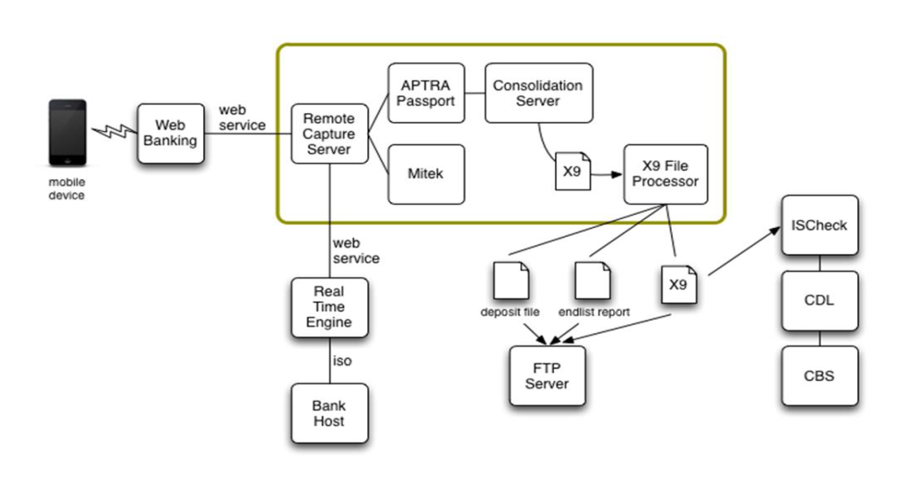

#### Messaging Flow

In the diagram provided by Central-1 below, the Kofax SDK will be integrated into the Mobile client. When a clean image is produced, the mobile client will send the image to the Infinity Digital Banking platform (Web Banking) and will orchestrate two calls (via Mule):

* Preprocess Deposit: As part of this process, various data integrity checks are done to ensure the cheque image can be deposited. This includes checks such as: bad image, amount mismatch, non Canadian item, invalid amount, missing rear image, inability to read MICR line, mismatch of user entered amount and what is read from the image, etc.
* Confirm Deposit: This finalizes the submission of the cheque, once the preprocess step has determined the cheque can be processed.
* *Note: CWB does not do real-time mRDC at this time and for R1 this will not change. All deposits are done in batch at end of day.*

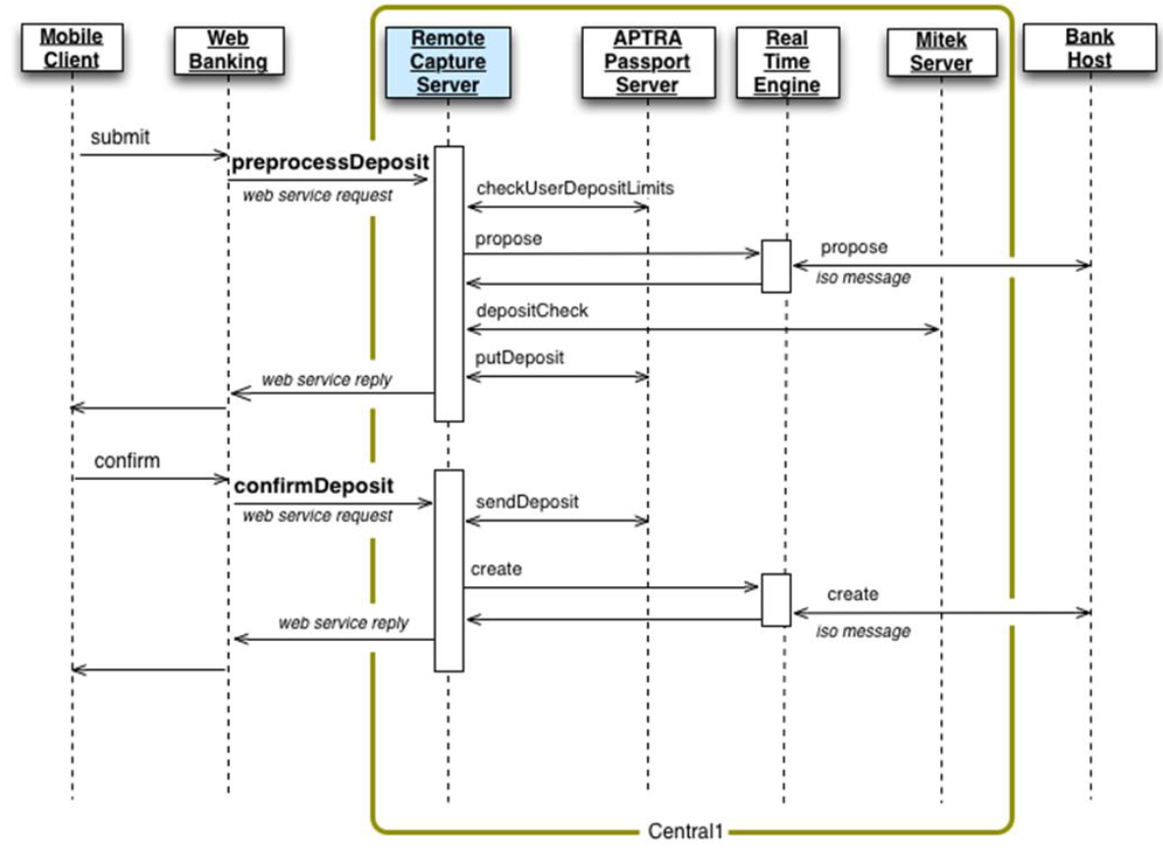

#### Kofax Mobile SDK



#### Central-1 mRDC Reference



### Employee Authentiation / Authorization

Native Infinity Spotlight employee authentication will be utilized for the first release. Subsequent releases will utilize Okta to authenticate employees before providing access to Spotlight. The Okta integration will be detailed in this section during a later release.

### Infinity User Activity Extract/Integration - TODO

Raised with Temenos that we need to extract this information and supply to downstream systems such as our AML, SIEM.

TODO: George will document how this will happen

* Working with Jack @Temenos to determine if we can identify a common way to solve for Fraud, AML and SIEM

### Bill Pay Master Vendor List

The Master Bill Payee List is stored in T24 and will be retrieved and cached in Mule on a daily basis. Mule will refresh this list independent of a customer inquiry, ensuring a use’s login experience or transaction response times are not affected by a caching refresh process.

Infinity will call Mule when searching the master vendor list. Filtering will be applied to retrieve a subset of bill payees based on filter criteria. For example,for small business, Infinity will need to retrieve a list of CRA and Alberta Tax payees, or Infinity will need the full list of payees that are not CRA or Alberta Tax payees. This will be worked out in detailed design.

### Flinks Integration – Post MVP

Flinks will be utilized to help establish Me2Me accounts for a customer. Online banking will integrate with the Flinks Connect widget to authenticate users with their existing non-CWB online banking relationships. Once the user is authenticated, Flinks APIs are utilized to retrieve accounts that can be utilized for EFT payments.

This is an existing integration established by the Digital Client Onboarding solution. This same solution can be reused for Digital Banking. No architecturally relevant changes are anticipated, so this solution is not repeated here.

### Celero/DOXIM

DOXIM contains CWB’s “on-us” cheque images and electronic statements. Celero will build a new API to expose this to CWB. A CWB API will be built via Mule to expose this API to Infinity. The primary functions of this API will be to search and download cheque image and electronic statement documents when requested by a user.

### Transfers

This is core banking functionality. All immediate, future-dated and recurring transfers will occur in T24. Existing ISO messaging will be leveraged wherever possible.

#### Manage Recipient

Infinity will persist transfer recipient data. T24 does not support this functionality in R12. Some future consideration may be given to moving this to T24 when it is upgraded to the latest release.

### eTransfer

Central-1 will remain CWB’s payment provider for e-transfers. There are several notable architectural considerations going forward:

* Infinity will integrate with C1 (via Mule) via a CWB e-transfer API. See Central-1 E-Transfer Reference below.
* While transitioning from MemberDirect to Infinity, there will be a period of time where both systems will be active. However, a user can only be active on one system. An interim page must be developed to direct users to MemberDirect or Infinity based on whether they have been migrated. See System Redirect below.
* Infinity will not store an e-transfer information, including e-transfer recipients
* All communications with the T24 core banking sytem will continue to utilize ISO8583
* Central-1 will continue to provide interac fraud tools via FAS (alert management) and OAS
* CWB will develop a fraud solution that will capture event details that will be assessed by the CWB fraud solution. E-transfer events have been prioritized for MVP.

#### System Redirect Page

CWB must establish an interim page that will allow a user to be redirected to either the Central1 Online Banking solution or the Infinity Online Banking solution, depending on which system they currently have access to.

**Process Flow**



**Component Impact**

* Infinity
  + Develop page to capture a username
  + Username is validated against Okta (using a Mule API)
  + If the username exists, then the user is forwarded to the Infinity home page, with the userame pre-populated. The user will enter their credentials and accept the e-transfer as usual. If the username doesn’t exist in Okta, then the user is forwarded to Central-1 MemberDirect with the username pre-populated (if possible).
* Mule
  + Reuse an API (developed for DCO) to determine if a user exists in the Okta repository based on the username.
* Interac
  + Work with Interac to redirect the user to a newly supplied URL that directs the user to the e-transfer redirect page. This must be coordinated with Interar for MVP. The interim page can be removed once all users have been migrated to Infinity.

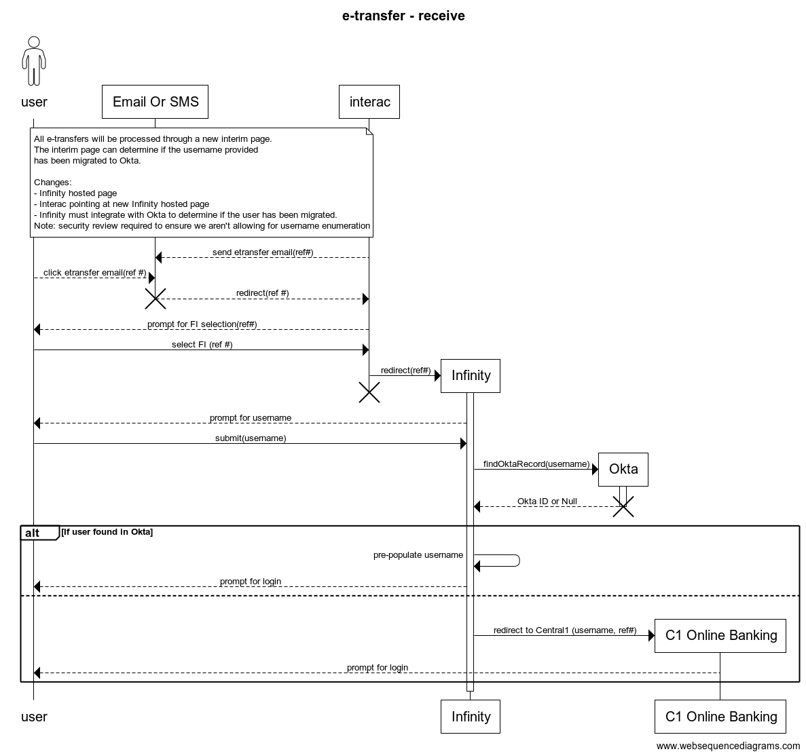

#### Central-1 E-Transfer Reference

CWB is migrating to the CWB e-transfer API vs the ISO messaging currently in place. The e-transfer API is attached below and is comprised of a comprehensive set of functions that enable this interact functionality. It is summarized in the following generalized capabilities:

* Customer Management - Allows a participant to manage a customer's profile. This includes the ability to register a new customer at Interac.
* Contact Management - Allows a participant to manage a customer's contacts. This includes the ability to create a new contact.
* Incoming e-Transfers - Allows a participant to process incoming e-Transfers. This includes the ability to complete (receive) an e-Transfer.
* Outgoing e-Transfers - Allows a participant to process outgoing e-Transfers. This includes the ability to send an e-Transfer.
* Money Requests - Allows a participant to process requests for payments. This includes the ability to send a request for payment to a customer's existing contact.
* Direct Deposit Registrations - Allows a participant to manage a customer's direct deposit registration details.
* Schedule e-Transfers - Allows a participant to manage a customer's e-Transfer schedules. This includes the ability to schedule e-Transfers to a customer's existing contact.
* Tools - Utilities and tools provided as a convenience to a participant.



### Account Details

T24 ISO8583 messaging supports the retrieval of accounts based on a user’s PAN. The PAN determines determines which accounts a user is authorized to retrieve. PAN’s are either directly stored on the Okta record (for retail users) and are leveraged in the Mule API built for Digital Bankikng, or are derived for small business banking based on the personal CIF of the user and the business CIFs associated to their Virtual Company. No significant changes are anticipated to the T24 ISO messaging that supports this capability.

### Account Nickname

T24 ISO8583 messaging supports the update of account nicknames. These nicknames apply to the account regardless of the user making the change and are reflected on customer statements. No significant changes are anticipated to the T24 ISO messaging that supports this capability.

### Account Dashboard

The Infinity platform presents a dashboard to retail, SBB and combined users. Infinity is responsible for orchestrating external calls (e.g. account details via Mule/T24) and internal calls (e.g. notifications, messages, etc.) to be presented on this dashboard. Combined dashboards will conmbine both retail and small business capabilities and present this information accordingly.

### Transaction and Audit Logs

All activity performed by customers and employees must be logged. Details of the specific transaction executed and the capture of device information is essential for audit purposes and enterprise fraud, aml and security monitoring. Infinity must provide the necessary functionality to present this information to an authorized user and must also be able to integrate with fraud, aml and SIEM solutions in near real-time. The details of the fraud/AML/SIEM integration will be captured in a different document and referenced in the Security, Fraud and AML section of this document.

### Content Management and Advertisements

The Infinity platform is responsible for the configuration and presentation of context based content and advertisements. The meta-data for this content, including text and media will be hosted with the Infinity platform. This applies to both pre-login and post-login content on both online and channels.

### Data Management

Various customer details will be maintained via Infinity/Spotlight screens. Analysis has occurred to determine system of access, the system of record, where data will be cached, etc. This is recorded in the Data Architecture and Migration section. Several key topics are highlighted here as they have a direct bearing on the solution.

#### Address Validation

Address updates should be validated by Infinity before persisting in T24. This will be achieved with the Canada Post address validation API built in the Digital Client Onboarding Phase of the project.

#### Email

Email updates should be permitted and then stored in Infinity, T24 and Okta. This will help ensure that the user receives alerting from Infinity and Okta. Email will also a necessary attribute for the forgot password flow, once it is enabled in a future release.

#### PAN Replacement, Termination & Reissue

It is recommended for MVP to solve for this through manual business processes. For this limited release, PAN updates are not expected to be frequent. An automated solution is required for future releases.

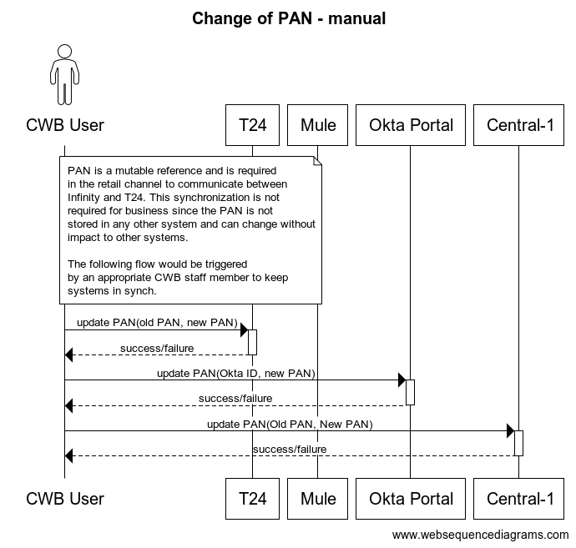

#### Replicate Customer Details from T24 to Okta – Awaiting Use Cases

TODO: Need to find a way to replicate this from T24 to Okta to keep in synch. George is looking into this, but should it be the IAM team responsibility?

This data won’t be used by Infinity directly. They will call T24 directly for names, address, etc.

## Integration Architecture

At the centre of the CWB integration architecture is the Mule API Gateway. CWB will follow a methodical way fo connecting data to applications, leading to reusable and purposeful APIs. The resulting 3 tiers of APIs will allow for reuse across the enterprise and a means of adapting APIs to the specific needs of a consuming application. This also avoids the common pitfalls of point-to-point integration.

The common pattern in the CWB Digital Program will be to build System APIs for all of the systems of record and Experience APIs for each consuming application. Process APIs will be developed where a more coarse grained API can be identified that is commonly reusable across the enterprise that also generally includes orchestration across multiple System APIs.

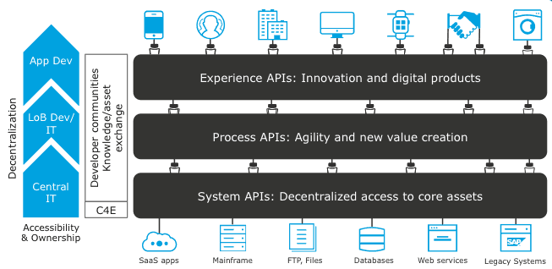

The content in this section will primarily focus on non-standard integrations from CWB systems/applications to internal or external components. Fourth party integrations are excluded.

Several additional integrations are also included that are not initiated through Mule APIs. For example, Flinks is a fintech that supports the online banking login and retrieval of account information for many Canadian FIs. The integration with this partner is initiated through a UI widget, therefore, the integration is direct from browser to Flinks. Additional information is collected from Flinks subsequent to a validated authentication.

### Overview Diagram



### API Security

The following document was produced in collaboration between Digital and Security Architects. The recommended API security controls embedded in this document will initially be established during the Digital Banking project and will enforce the security of CWB experience APIs.



### CloudHub Architecture

For the Digital Program and as an ongoing direction for CWB’s integration architecture, Mulesoft Cloudhub will be utilized for integration. CWB will no longer utilize on-premise Mule runtimes. The following diagrams describe the physical and network architecture of CloudHub.

#### Physical Reference Architecture

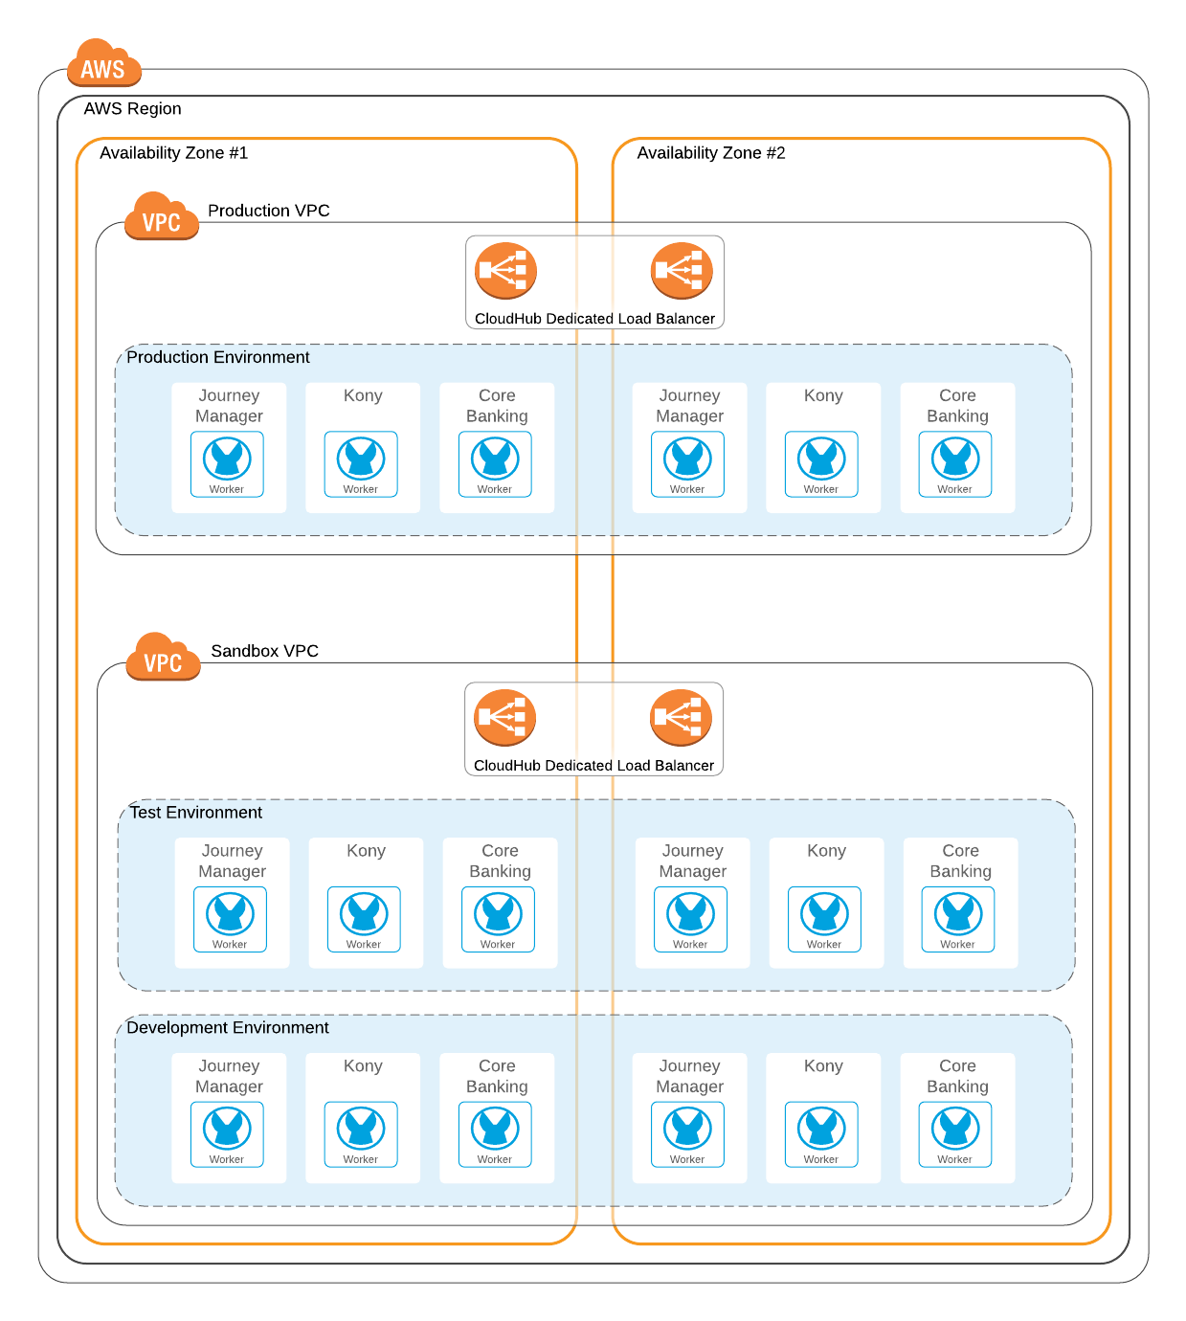

#### Private Network Architecture

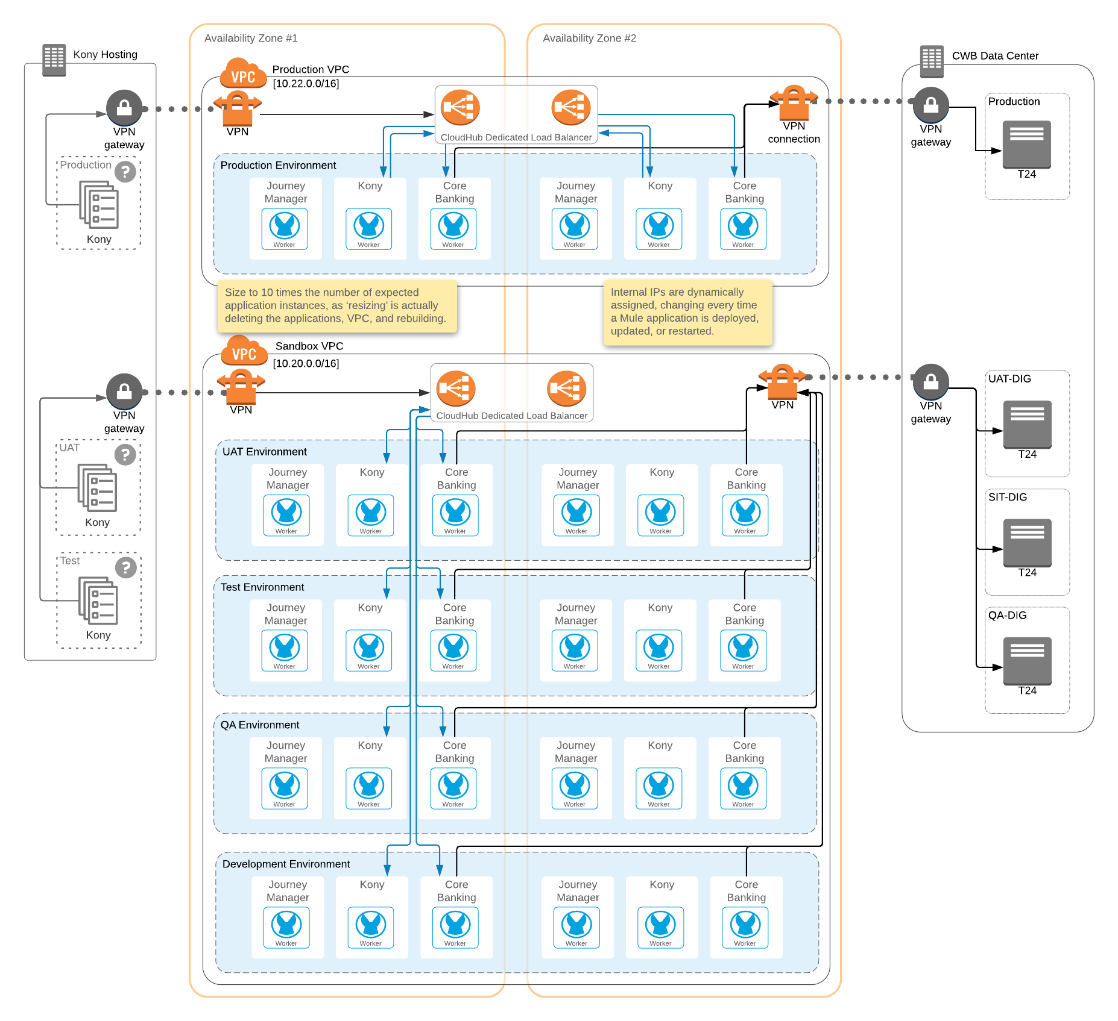

#### Network Layer Security

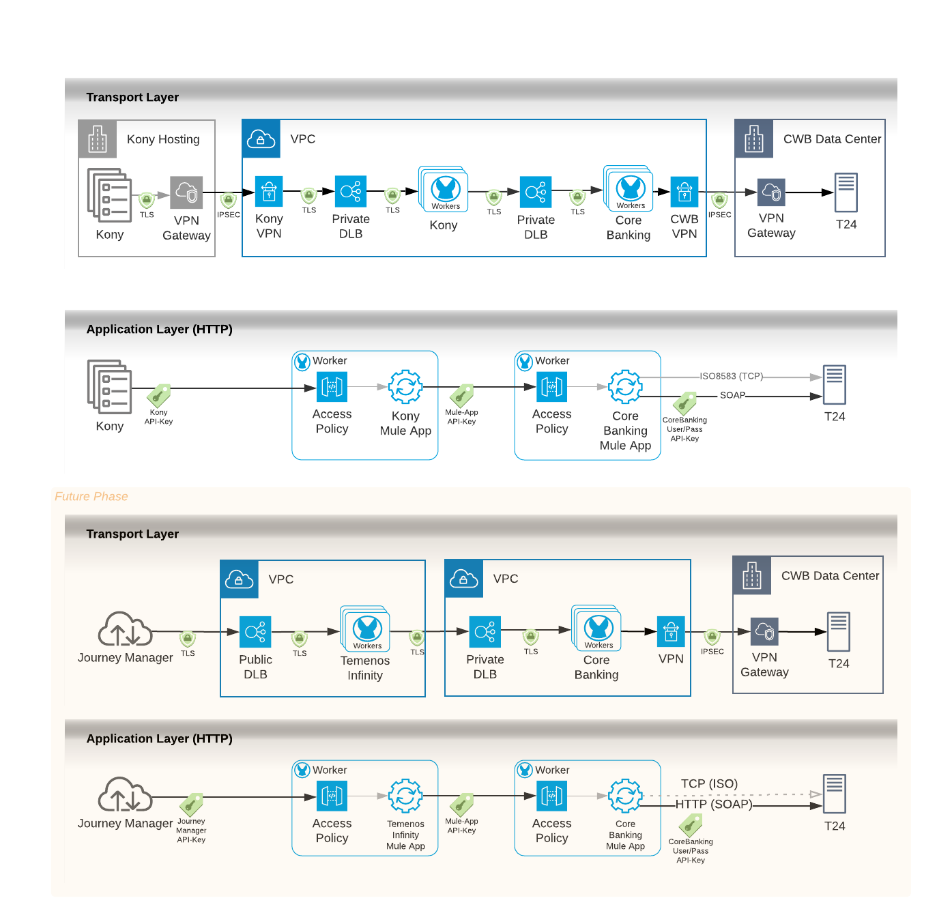

### Standard Integration Pattern

The typical pattern for integration will be as indicated in the sequence digram below.

In some rare cases, applications may be permitted to integrate directly. This will generally only be done in the following cases:

* Where an out of the box integration is already available between components (e.g. Infinity to Twilio)
* Where two separate products are acquired by a single vendor and the immediate roadmap is for these applications to run on the same platform (e.g. Avoka and Kony acquired by Temenos are now branded the Infinity Platform).

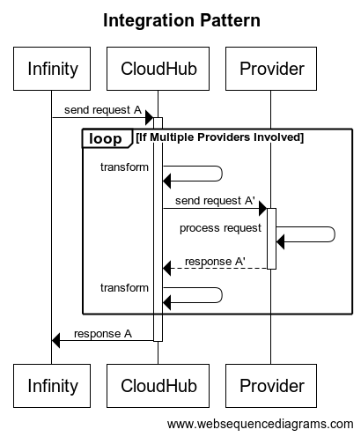

### Error Handling Practices

Multiple application tiers are part of any request from Infinity to provider systems (such as T24). The following decisions introduced during the initial phases of the Digital Program in support of Digital Client Onboarding will be followed where possible to support troubleshooting and an accurate understanding of where errors have occurred.

* All Channels will validate data at time of entry to reduce potential for downstream errors
* Experience APIs hosted by Mule will remain relatively “granular”, allowing the Channel to orchestrate the API requests as per the business requirements. Orchestration may occur at the Mule layer where it is benefical to the overall reuse of the APIs being built or to simplify the consumption of APIs from the channel.
* Errors raised by a provider system, or by Mule itself, whether technical or business oriented will be propagated up to the channel with sufficient detail to determine the error code, and its classification (business or technical).
* Infinity will not display internal error details that could potentially compromise CWB systems.
* Automated retries will generally not be implemented at any layer due to the lack of idempotency in the T24 core banking system and the potential to create duplicate records. If a scenario is identified where an exception clearly identifies a scenario where an automated retry can be attempted, then it should be attempted.

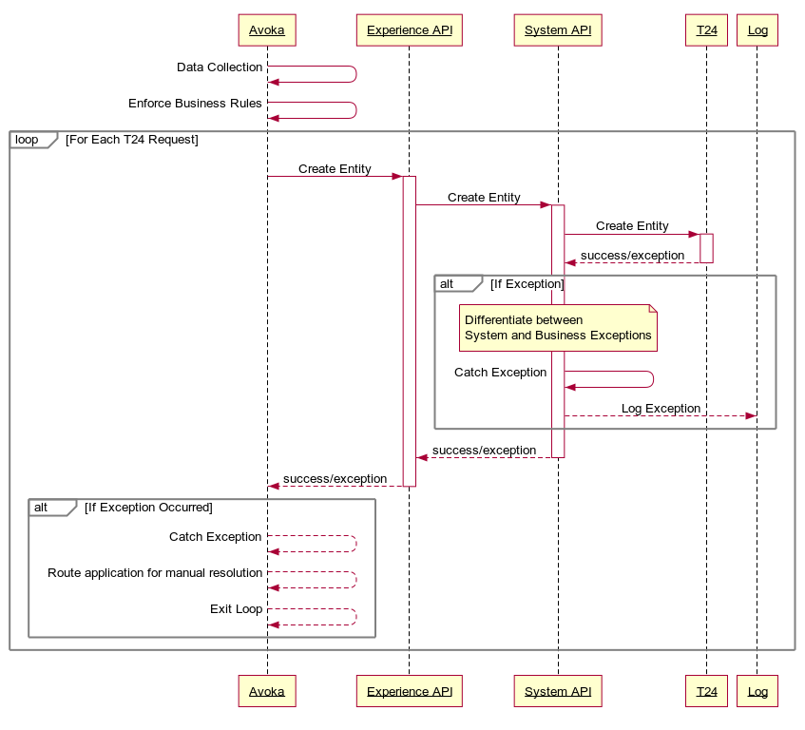

### Mock APIs for Testing

Mock APIs will be established to help the CWB Quality Assurance team test edge cases in pre-production environments that are otherwise difficult to test, given the wide variety of third parties involved in the end-to-end solution. A Mocking framework has been established, allowing a QA tester to direct requests to a specific API Mock endpoint when testing a scenario. Infinity will accept http parameters indicating which endpoint(s) should be redirected to a Mule hosted Mock endpoint. Mule will configure a variety of response types, which will be selected based on content in the original request. The Mock services will sit at the “Experience API” layer. The Mock services will load response files from a local folder on the Mule Runtime server. Group access will be provided to the folder which will permit an individual to load files for mock service testing.

At this time, Mock testing will be limited to the Partner QA Environment and the CWB SIT Environment. Infinity Mock parameters and Mule Mock services will not be deployed to the CWB UAT and Production environments.

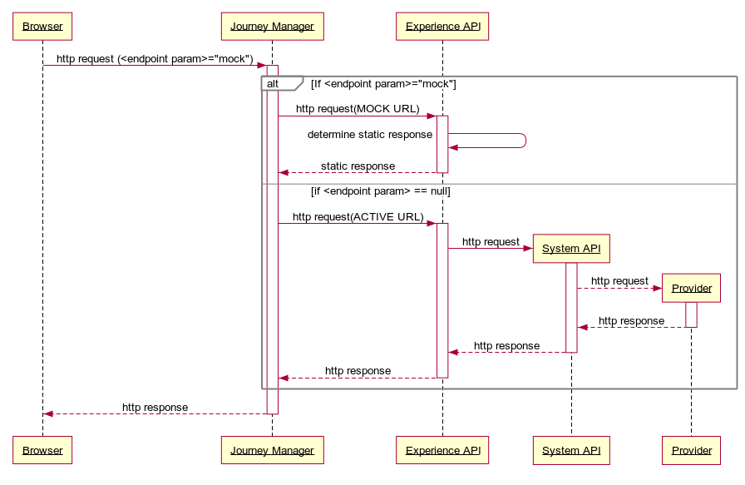

### Summary Integrations

TODO: Mark D is summarizing integrations – target week of Feb 8th.

#### File Based/Batch Integrations

|  |  |  |  |  |  |  |  |
| --- | --- | --- | --- | --- | --- | --- | --- |
| **Source** | **Target** | **Facilitated By** | **Status** | **Occurance** | **File Type** | **Protocol** | **Security** |
| Avoka Platform (AWS) | CWB Datacentre | Computer Operations via Powershell Scripting | New | Event Driven | Zip File | sFTP | PGP Encryption |

#### Real-time Widget/Javascript Integrations

|  |  |  |
| --- | --- | --- |
| **Function** | **Provider** | **Type** |
| Okta Widget | Okta | Widget javascript  For Mobile this is embedded in a webview |
| Flinks Logon Widget | Flinks | Widget javascript embedded in iFrame |
|  |  |  |

#### Real-Time Integrations

|  |  |  |  |  |  |  |
| --- | --- | --- | --- | --- | --- | --- |
| **Function** | **Provider** | **Protocol** | **Transport Security** | **IP Whitelisting** | **Access Security** | **API Reference** |
| Busienss Credit Card | Collabria | SOAP | TLS 1.2 | Yes | * Session Token * Username/password to retrieve a Session Token |  |
|  |  |  |  |  |  |  |
|  |  |  |  |  |  |  |
|  |  |  |  |  |  |  |
|  |  |  |  |  |  |  |
|  |  |  |  |  |  |  |
|  |  |  |  |  |  |  |
|  |  |  |  |  |  |  |
|  |  |  |  |  |  |  |
|  |  |  |  |  |  |  |
|  |  |  |  |  |  |  |
|  |  |  |  |  |  |  |
|  |  |  |  |  |  |  |
|  |  |  |  |  |  |  |
|  |  |  |  |  |  |  |
|  |  |  |  |  |  |  |
|  |  |  |  |  |  |  |
|  |  |  |  |  |  |  |
|  |  |  |  |  |  |  |
|  |  |  |  |  |  |  |

## 

## Data Architecture and Migration

Details related to migration strategy, migration scope, technical architecture, etc. are all found in the following [location](https://sp.cwb.local/projects/pmo2/Digital%20Program/SitePages/Home.aspx?RootFolder=%2Fprojects%2Fpmo2%2FDigital%20Program%2FDigital%20Program%20SharePoint%2F3%20Digital%20Online%20Banking%2F1%20Small%20Business%20DOB%2F1%20Analysis%2FData%20Migration&FolderCTID=0x0120000EE3FC2186448C45940CA2A92BDE78D3&View=%7b1F9A4661-F399-4CC3-891A-167602AE1583%7d&InitialTabId=Ribbon%2ERead&VisibilityContext=WSSTabPersistence) and will not be elaborated on in detail in this section. This section highlights some of the key architectural guidance to support a successful migration in the Digital Banking project and the placement of data across the new and old components of the Digital and Core Banking architectures.

As part of detailed design, every target will have a source to target mapping specification. Data discovery and data clean-up documents will be produced where required. A C1 data model and data dictionary has been developed by the CWB team, since they were not assets available from Central-1. As the migration team works with the target systems to shore up the target designs and processes, further technical details, including: triggering, error tracking, back-out procedures, disaster recovery, audit processes, etc. will be elaborated on by the migration team.

### Architectural Guidance

The following specific migration guidance is provided by Architecture:

* Small businesses, including all T24 users and Delegates for that business must be migrated as a whole from Central-1 systems into CWB systems
* Migration shall not include credentials. This will be done in real-time at first login, where Okta will reach out to T24 or Central-1 to authenticate existing users with their current credentials.
* Users must be blocked from accessing Central-1 systems once they have been migrated.
* Migration scripting must allow for batches of migrations over a period of weeks or months.

### Data Placement Diagram

The following diagram is provide as input to the migration design activities to ensure a full understanding of which date entities are being migrated and where these entities land in the overall architecture. The overall legend for this diagram is as follows:

* Yellow – Migrated data (from)
* Orange – Migrated data (to)
* Dark Green – Cached Data (to)
* Light Green – Cached Data (from)
* Dark Purple – Replicated Data (to)
* Light Purple – Replicated Data (from)
* Blue – Data originates and remains in this component



### Logical Process Flow



### Data Migration Context



### Systems of Record & Systems of Usage

The following detailed spreadsheet was developed in conjunction with the Infinity, T24 and Okta teams to identify systems of record, systems of usage, systems caching data, etc. It is an accurate reflection of our current understanding. Interactions between systems, API specifications/processes, etc. are developed with this guidance in mind.



### Information Classification

As per Section 2.2 of the [Information Classification Standard Document](https://sp.cwb.local/departments/is/is/ss/Shared%20Documents/Policies,%20Standards,%20Procedures,%20Processes/Information%20Security%20Standards/Information%20Classification%20Standard/Information%20Classification%20Standard%20January%202018%20Final.pdf), the data handled by the onboarding process is considered classified as **Level 3: Confidential**. All necessary security controls for classified data will be followed when in transit or stored.

## Technical Architecture – In Progress

The Digital Banking technical architecture is comprised of 5 major areas.

**Infinity Digital Banking Platform**

The Digital Banking experience for Motive, CWB Retail and CWB Small Business are built on the Temenos Infinity Digital Banking Platform. CWB has entered into a contract with Temenos to host and manage the non-prod and production environments in the Temenos Azure-Hosted Cloud Environment. Several deployment options have been discussed and one recommended by the Architecture and Security Teams. The details of this are provided in the sections below.

**Mule / CloudHub**

The Mule API Gateway will be the primary means of integrating with CWB internal and external partners. Mule CloudHub, the IPaaS from Mule, will be leveraged for all integration needs. No on-premise Mule runtimes will be utilized for this solution. The CloudHub architecture established during this project, for reuse across all future CWB initiatives is found in the Integration Architecture -> CloudHub section of this document.

**External Providers**

External providers are generally provided as SaaS solutions. Each is vetted against CWB standards and is subject to GRC review. Generally, secure protocols as TLS 1.2 and API keys are utilized to connect to each of these partners. No further details of the technical architecture are described in this document.

**Internal Providers**

Internal providers such as T24 Connect, SAS AML, Proofpoint and Microsoft Exchange all have established technical architectures. Additional environments have been established for T24 Connect to facilitate testing and SOAP API development, but no additional changes have occurred to the architecture of any other internal providers. The Fraud Solution is a dependency for this project, but will be detailed in a separate document. No further details are provided in this document.

**Migration**

Technical Architecture supporting migration can be found through the Migration section of this document. No further details are provided in this document.

### Environment Purpose/Definition

In partnership with the Digital Banking implementation partners Kony/Temenos, Bits and Glas, Okta, CWB application development, CWB Application Management Services and CWB Quality Assurance the following environments have been defined in support of the project SDLC and operational support activities:

#### Project Environments

**Mock** – Mock API services are enabled for rapid initial integration for Temenos developers of the Digital Onboarding Solution. Limited static test data is available through Mock services.

**Partner Local Development** – Partner development workstations, inclusive of Temenos and BIG are included in this environment. This is a non-integrated environment

**Partner Development** – Partners deploy unit tested code to these environments. They may be integrated with CWB systems to improve the unit test quality.

**Partner QA** – This is the first integrated environment, containing code from Temenos, BIG and T24. The partners use this environment for integrated testing, prior to releasing the code to CWB for further quality assurance.

**CWB SIT** – CWB coordinated System Integration Testing.

**CWB UAT** – CWB coordinated user acceptance testing, non-functional testing, penetration testing, etc.

#### Operational Support Environments

**CWB Operational Support 1** **–** CWB coordinated **functional** testing of production defect fixes or minor production enhancement.

**CWB Operational Support 2 –** CWB coordinated **regression** testing of production defect fixes or minor production enhancements.

#### Production Environment

**Production –** The customer facing production environment.

The detailed environment alignment is collected in the following [spreadsheet](https://sp.cwb.local/projects/pmo2/Digital%20Program/Digital%20Program%20SharePoint/1%20Program%20Management/03.%20Execution/01%20Design/Architecture%20Design/Environments/Archive/Digital%20Banking%20Environment%20Map.xlsx) and shows which environments are used in each phase of the development lifecycle. This detailed information will evolve over time and will be put in place as required in the SDLC process.

### Project and Operational Support Environment Diagram – High Level Pattern

The following diagram depicts the general digital project and operational support environments. Not all downstream applications are listed in this diagram due to the potential complexity and in particular Okta is missing from this diagram. The detailed matrix is a living document as alignment is concluded with all downstream providers.



#### Matrix

The environment matrix is a living document and is maintained in the following [location](https://sp.cwb.local/projects/pmo2/Digital%20Program/Digital%20Program%20SharePoint/1%20Program%20Management/03.%20Execution/01%20Design/Architecture%20Design/Environments/Archive/Digital%20Banking%20Environment%20Map.xlsx). This will be enhanced whenever additional 3rd party services/environments are added to the Digital Banking scope.

### T24 Project and Operational Support Diagram

The Digital Onboarding program has introduced 3 new T24 environments. The purpose of these environments is to ensure the Digital Program and its related projects can independently develop and test features with reduced contention across all CWB projects/initiatives. It will generally be true that any code developed in the digital program will also need to be tested in the operational environments to ensure all systems dependent on T24 are regression tested when relevant changes are introduced by the program. This will commonly occur at the end of a series of digital program (onboarding or digital banking) sprints, when a significant release of digital enhancements are to be released. There may be some cases where code can be deployed from the digital environments directly into production, but it is not typically the rule.



### Technical Infrastructure Overview/Design

The basic infrastructure design that supports secure communication between the core components of the Digital Banking solution is provided below. It focuses on the key components of Infinity, CloudHub, Okta, T24 and third party services.



### Infinity

CWB has entered into an agreement with Temenos to host and manage the Digital Banking application on behalf of CWB. The cloud environment is part of the standard Temenos Cloud offering hosted on Azure and is reprented by the following diagram. CWB has requested further elaboration on the diagram and its constituent parts, as well as an update to accurately reflect the security boundaries in play. In general, CWB has not found any particular issues with this architecture, which is also supported by a 2020 SOC2 report (held by CWB InfoSec team).

[1]

To support the unique nature of CWB’s digital business, where CWB is using the platform to support Motive and CWB channels, Temenos will provide the following architecture:

* 5 UI code bases
* 1 for Online Banking that will be shared between CWB Personal DB and Motive DB,
* 2 for Android and 2 for iOS to support app registration for Motive and CWB under different app names.
* 1 Fabric instance
* 1 Spotlight instance

### Directory and Identity Services

#### DNS - TODO

The Infinity front end domain will be hosted by <TBD>

CWB APIs expose a domain and API endpoints to the Infinity platform. The CWB Cloudflare DNS is used for all public facing domains.

#### Active Directory

The employee facing component of Temenos Spotlight will initially utilize the authentication capabilities of the Infinity Platform. Integration with Okta will occur as soon as possible using the OIDC protocol. Details of that integration configuration are identified and solved by the IAM team.

#### User Accounts / Group Name

The Infinity Platform provides a roles and permissions based security authorization model for system administration functions. Organization administrative users can belong to multiple roles, which in turn contain a series of permissions that will enable these user to access components of Spotlight.

Roles and permissions will be defined and configured in consultation with the CWBFG Identity and Access Management practice.

#### Service Accounts - TBD

Accounts/groups should be unique to each environment (DEV, TEST, PROD). Naming standard to be applied by the IO group.

|  |  |  |
| --- | --- | --- |
| **Account Purpose** | **Active Directory Accounts** | **Password Managed** |
| SFTP Batch Integration Script | TBD | Active Directory |

### Firewall Rules

#### Partner QA, CWB SIT, CWB UAT and Production

The rules should be applicable for Partner QA, CWB SIT, CWB UAT and Production environments.

Table 2 Firewall Ports

|  |  |  |  |  |  |  |  |
| --- | --- | --- | --- | --- | --- | --- | --- |
| **FIREWALL PORTS** | | | | | | | |
| **Source Address** | **Source Ports** | **Destination Address** | | **Destination Ports** | | **Direction** | **Purpose** |
| Administration | | | | | | | |
|  |  |  | |  | |  |  |
|  |  |  | |  | |  |  |
|  |  |  | |  | |  |  |
| **Inter nodes communication** | | | | | | | |
| Temenos Journey Manager (aka Avoka Transact) | >1023 | Citrix Load Balancer (External – DMZ Confidential) | | HTTPS | | Uni | Integration |
| Citrix Load Balancer (External) | >1023 | Citrix Load Balancer (Internal - Production) | | HTTPS | | Uni | Integration |
| SFTP Server | >1023 | Enterprise Storage (SAN) | | SMB | | Uni | Integration |
| Mule Runtime | >1023 | Citrix Load Balancer (Internal) | | HTTPS | | Uni | Integration |
| Mule Runtime | >1023 | Citrix Load Balancer (Internal) | | 4000-4002 | | Uni | Integration (ISO8583 Messaging Protocol) |
| Comp Ops Server | >1023 | Citrix Load Balancer (Internal) | | HTTPS | | Uni | Integration |
| Comp Ops Server | >1023 | Enterprise Storage (SAN) | | SMB | | Uni | Integration |
| Citrix Load Balancer (Internal) | >1023 | Mule Runtime (App Web Confidential) | | HTTPS | | Uni | Integration |
| Citrix Load Balancer (Internal) | >1023 | T24 SOAP Interface Server | | HTTPS | | Uni | Integration |
| Citrix Load Balancer (Internal) | >1023 | ISO8583 Interface Server | | 4000-4002 | | Uni | Integration (ISO8583 Messaging Protocol) |
| Citrix Load Balancer (Internal) | >1023 | Filenet | | HTTPS | | Uni | Integration |
| **Services and Resources** | | | | | | | |
| **Internet** | | | | | | | |
| Mule Runtime | >1023 | Flinks | HTTPS | | Uni | | Integration |
| Mule Runtime | >1023 | Thirdstream | HTTPS | | Uni | | Integration |
| Temenos Journey Manager (aka Avoka Transact) | >1023 | SFTP Server | SFTPs | | Uni | | Integration |
| **Security and Logging Services** | | | | | | | |
| Mule Runtime Servers | >1023 | Syslog Server Elastic | | UDP/20514, TCP/1468 | | Uni | Syslog - Elastic |
| TCP/6514 | | Uni | Secure Syslog |
| nms.cwb.local | | TCP/22 | | Uni | SFTP |
| **Directory Services** | | | | | | | |
| Mule Runtime Servers | >1023 | dc1.cwb.local  dc2.cwb.local  d4-dc1.cwb.loca | | AD | | Uni | AD, Windows services |
| NTP | | Uni | Time service |
| ica.cwb.local | | TCP/9090 | | Uni | CA PKI |
| OSCP | | Uni | CRL, OSCP |
| SCEP | | Uni | CRL, OSCP |
| dc1.cwb.local dc2.cwb.local d4-dc1.cwb.loca | | DNS | | Uni | DNS |
| ntp.cwb.local | | UDP/123 | | Uni | NTP |
| **Email and Communication Services** | | | | | | | |
| Temenos Journey Manager (aka Avoka Transact) |  | Proofpoint SMTP Relay | | TCP/25 | |  | SMTPs |
| **Monitoring** | | | | | | | |
| SCOMM | >1023 | Mule | | scomm | | Uni | Monitoring |
|  |  |  | |  | |  |  |
| **Email and Communication Services** | | | | | | | |
| Avoka Transact |  | Proofpoint | | TCP/25 | | Uni | SMTPS Relay |

### Certificates

The Avoka Transact URLs and Mule API endpoints will be accessed via HTTPS.

Public certificates will be provisioned for each of these applications.

Table 10 Certificate List

|  |  |
| --- | --- |
| **CERTIFICATE TABLE** | |
| **Prod** | |
| **Property** | **Value** |
| Friendly Name (FQDN) | NA |
| Installed on | NA |
| Issuing CA | ica.cwb.local |
| Certificate Encryption Strength | 2048 bit |
| Subject Alternative Name (DNS) | NA |
| Friendly Name (FQDN) | NA |
| Installed on | NA |
| Issuing CA | ica.cwb.local |
| Certificate Encryption Strength | 2048 bit |

# Security, Fraud, AML Architecture

## Security Architecture

The security architecture is documented separately from this document and will referenced via a link once complete. This will include an end-to-end view of digital banking security controls, including controls in place in the Temenos Cloud and Mobile In-App Security Controls.

Responsible Architect: Joanne and Roney

## Fraud Solutions

The fraud architecture is documented separately from this document and will referenced via a link once complete. This will include MVP fraud integrations with Navaera, a product selected to support enterprise fraud requirements.

Responsible Architect: Prakhar and Ravi

# System Management Design – Updates Required

## Monitoring, Logging, Traceability and Incident Management

### Overview Diagram



### Logging & API Traceability

Journey Manager will produce two unique IDs to help with the end-to-end correlation of log records. These two IDs are described as follows:

* Tracking Code – Represents the unique Reference ID generated for each customer application.
* Request Correlation ID – Represents the unique UUID generated for each API request.

These two values will be submitted by Journey Manager as HTTP header values with each API request to Mule. Ideally the two values are written to the log as two separated values. If this isn’t possible, then it is acceptable to combine them into one value. When doing so, the values must be separated by a pipe (vertical bar) delimiter (i.e. “|”).

Mule will receive the Tracking Code and Request Correlation ID in the HTTP header and will log both values at the Experience API level. The Request Correlation ID will be passed to all downstream APIs (Process API, System API, Provider API) and included in logs at each level.

Mule will also send the Request Correlation ID with each T24 request (Provider API). The T24 Interface will log this value as part of the T24 Interface logs.

The Elastic Search Stack will aggregate all logs from Journey Manager, Mule and the T24 Interface and effectively stitch together the logs, presenting an end-to-end flow of log activity.

#### Sequence Diagram

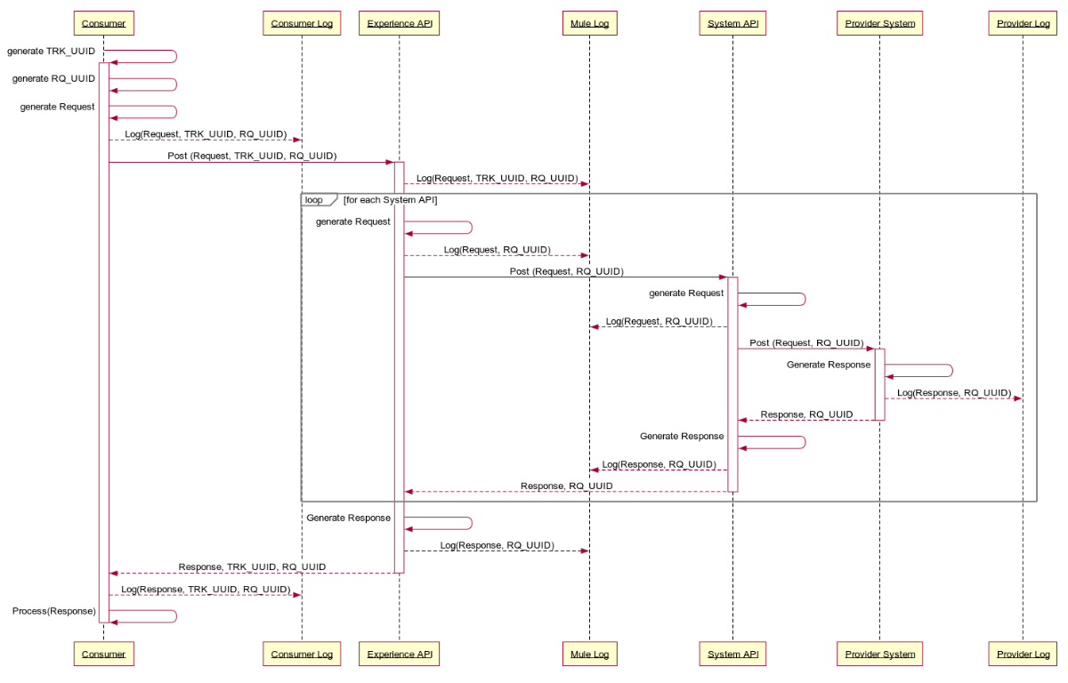

#### Sequence Description

The following sequence describes the responsibilities of each component in logging the tracking and request correlation IDs and passing the value(s) on to the next downstream component.

1. Journey Manager generates a Tracking Code (TRK_UUID) for a new customer application
2. Journey Manager generates the necessary API requests
3. For each request
   1. Journey Manager generates a Request Correlation ID (RQ_UUID)
   2. Journey Manager logs the request meta-data, TRK_UUID and RQ_UUID
   3. Journey Manager submits the request along with the TRK_UUID and RQ_UUID to Mule
   4. Experience API logs the request meta-data, TRK_UUID and RQ_UUID
   5. Experience API repeats the following for each System API call
      1. Generate the System Request
      2. Experience API logs the request meta-data and RQ_UUID
      3. Experience API calls the System API with the RQ_UUID
      4. System API generates the provider request
      5. System API logs the request meta-data and RQ_UUID
      6. System API calls the provider API with the RQ_UUID
      7. Provider API generates a response
      8. Provider logs the response meta-data and RQ_UUID
      9. Provider API returns the response to the System API
      10. System API receives the response
      11. System API generates a response
      12. System API logs the response meta-data and RQ_UUID
      13. System API returns the response to the Experience API
      14. Experience API receives the response
   6. Experience API generates a response for Journey Manager
   7. Experience API logs the response meta-data and RQ_UUID
   8. Exerience API sends response to Journey Manager
   9. Journey Manager receives the response
   10. Journey Manager logs the response meta-data, TRK_UUID and RQ_UUID
   11. Journey Manager processes the response

#### Mule Logging Guidance

Log errors, warnings, information and debug messages with standardized attributes, including relevant information (when, where, who, what) about the requests/responses in human readable AND machine parsable format. The following minimum information should be provided for troubleshooting purposes:

* + HTTP Header Information (including TRK_UUID, RQ_UUID where possible)
  + HTTP Query Parameters
  + HTTP Response Code
  + Log Date and Time (use a standard date and time format (ISO8601)
  + Event Date and Time (use a standard date and time format (ISO8601)
  + Application Identifier (e.g. Journey Manager – Motive)
  + Application Version (e.g. 1.1.1)
  + Environment (e.g. Production)
  + Application Address (cluster/host name, or server IP address and port number)
  + API/Resource Name
  + Request Direction (Akova -> Mule | Mule -> Akova), a.k.a. Request or Response, remember we aren’t logging at the HTTP layer just the message bodies
  + Payload/Meta-data (See guidance on *Sensitive Information* below)
* Sensitive Information should not be logged. In some cases partial masking or hashing of data may be permissible to help with troubleshooting purposes, in which cases the word “masked” or “hashed” will be included in the list below. These exceptions should be discussed with Architecture and Security. Data not to include in logs include:
  + Application source code
  + Session identification values (hashed)
  + Access tokens
  + Sensitive personal data and some forms of personally identifiable information (PII)
  + Authentication passwords
  + Database connection strings
  + Encryption keys and other master secrets
  + Bank account or payment card holder data (masked)
  + Data of a higher security classification than the logging system is allowed to store
  + Commercially-sensitive information
  + Information it is illegal to collect in the relevant jurisdictions
  + Information a user has opted out of collection, or not consented to e.g. use of do not track, or where consent to collect has expired

### Monitoring

#### Mule – Native Monitoring

As part of Anypoint Platform, Anypoint Monitoring provides visibility into integrations across the CWB app network. The monitoring tools provide feedback from Mule flows and components in the app network.

Operations and development teams will use the monitoring tools to diagnose issues and prescribe solutions to behavior that negatively impacts digital performance. The monitoring tools are designed to reduce the time to identify and resolve these issues through aggregated metrics, data visualization tools, alerts for issues, and a log aggregation system. Specifically, Anypoint Monitoring provides ways to:

* Aggregate and map metrics across dependent systems in real-time.
* Configure dashboards and alerts to reduce the mean time to identification of issues (MTTI).
* Store and search log data at scale.

#### Mule - API Functional Monitoring

The Mulesoft API Functional Monitoring solution enables developers and operators to perform consistent testing of the functional behavior and performance of CWB APIs, throughout the API lifecycle, in testing and production environments.

The solution helps you carry out the following tasks:

* White-box testing: This type of testing validates the behavior of individual APIs against the understanding of how their internals work. As part of this type of testing, you mock and simulate dependencies (for example, back-end systems and other APIs).
* Black-box testing: This type of testing validates the overall behavior of an API and its real/live dependencies as a whole, based purely on inputs and outputs (i.e. without knowing or altering the API internals - no simulation or mocking).
* Runtime monitoring: This type of monitoring ensures that deployed APIs are operating within expected performance in production environments. It makes use of behavioral test cases that use real inputs and expected outputs, and exercise dependencies, as in black-box testing.

CWB will leverage **Runtime monitoring** to validate the expected performance in a production environment. APIs monitored for this purpose must provide a set of *non-destructive data* that can be utilized to test the functionality of the API, but not impact downstream provider systems.

#### Mule – Alerting

The CWB Integration team will define and trigger alerts based on rules (or thresholds) and policies for CWB API resources. When these thresholds are crossed for a certain period of time, CWB will receive notification to take action.

All Mule generated alerts will be routed to the ServiceNow IT Operations Management module to enable centralized incident management. The Mulesoft ServiceNow connector will be leveraged to integrate with ServiceNow and create events upon which the SericeNow (based on configuration management) can update relevant dashboards, determine if an incident should be auto-generated or if a manual review is required before an incident is created.

#### Mule – SCOM Monitoring

Java Application Performance Monitoring (APM) in System Center - Operations Manager lets you monitor Java applications to get details about application performance and exception events that can help determine the root causes of problems. The System Center Management Pack for Java Application Performance Monitoring lets you monitor Java application performance and exception events by using Operations Manager Application Advisor. With Operations Manager Application Advisor, you can investigate method and resource timing for performance events, stack traces for exception events, Java-specific counters for events (such as Average Request Time, Requests Per Second, JVM Memory, and Class Loader), and run some of the standard Application Performance Monitoring reports.

#### Mule – ServiceNow Integration

The Event Management application is part of the IT Operations Management (ITOM) area, which also covers CMDB Discovery, Service Mapping and Orchestration. With the Event Management application CWB integrates multiple monitoring sources, and create ServiceNow events out of it.

SCOM will be integrated in this fashion to provide meaningful dashboards to operational staff and ensure there is a fulsome view of application and server health for the Mule runtime and Mule applications.

#### Mule - Health Check

A health check endpoint will be defined that can be used by systems to verify that a Mule runtime is operational and can accept new requests. Ideally, the health check will also provide additional details that can be leveraged by advanced load balancers to route requests to instances that are not only healthy, but are in the best position to accept the next request (e.g. combination of lowest: CPU utilization, memory utilization, response times, etc.)

## Log Aggregator Integration

All logs will be aggregated by the Elastic Stack in near real-time. The Elastic Stack will be configured to read events from the AWS SQS queue (see [SQS Input Plugin](https://www.elastic.co/guide/en/logstash/current/plugins-inputs-sqs.html)), Mule servers (see [Filebeat](https://www.elastic.co/beats/filebeat)) and T24 logs and indexed as required for both the Security Operations and Digital Technology Services Teams. The Digital Technology Services team will write queries to correlate and show the full relationship between Journey Manager, Mulesoft and T24 transaction logs. See the Logging & API Traceabilty section for further details on how transactions across systems are correlated.

The Journey Manager System Event Publisher will publish key system events to a **single** AWS SQS event queue, one for **production** and another for **all non-production** environments. The CWB Elastic instance will pop off events from this queue at a pace it can manage, parse the messages and store the content as required for indexing, searching and reporting.

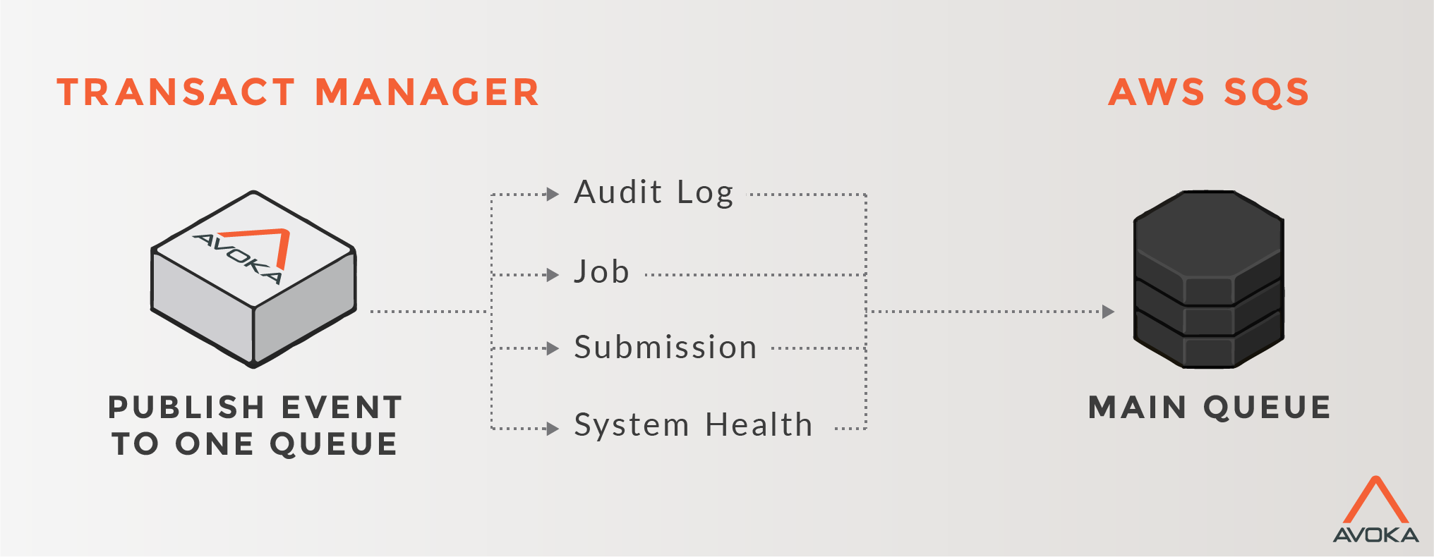

Connectivity to SQS from the CWB Elastic Stack must be secured in transit via TLS 1.2 and encrypted at rest. Access to this data must also be restricted by role and limited to a small subset of CWB employees on a need to know basis. Special care must be taken to follow the CWB Data Protection Standard [2] to ensure sensitive customer data is handled according to this standard.

Event types supported by Journey Manager are summarized below ([reference](https://docs.avoka.com/SystemEventPublisher/SystemEventPublisherEvents.htm)), along with the CWB party that derives the most value from consuming, indexing and searching the event.

|  |  |  |
| --- | --- | --- |
| **Event Type** | **Interested Party** | |
|  | **Security Operations** | **Digital Technology Services** |
| Audit Logs | High value | Low value |
| Collaboration Job Events | Low value | Low value |
| Transaction Events | High value | Low value |
| System Health Events | Low value | High value |
| User Authentication Events | High value | High value |

Event messages are published in JSON format as defined by the [System Event Publisher](https://docs.avoka.com/SystemEventPublisher/SystemEventPublisherEvents.htm) specification.

## Service Level

Refer to **APPENDIX E - Service Level Objectives Responsibility Matrix** for more details.

|  |  |  |  |  |  |
| --- | --- | --- | --- | --- | --- |
| AVAILABILITY AND PERFORMANCE STANDARDS | | | | | |
| Network Area | **Availability Target** | **Measurement Method** | **Avg. Network Resp. Time Target** | **Acceptable Resp. Time** | **Response Time** |
| LAN | 99.99% | Impacted user minutes | Under 5 ms | 10 ms | Round-trip ping response |
| WAN | 99.99% | Impacted user minutes | Under 100 ms | 150 ms | Round-trip ping response |

## Service Priority

|  |  |  |  |
| --- | --- | --- | --- |
| SLA-SLO MATRIX | | | |
| **Priority** | **Response Time** | **Resolution Time** | **Penalty** |
| Medium -2 | 15 min | 24 hrs | NA |

## Systems Management

### Application Management

The Mule systems are managed via the application servers’ web interface. Journey Manager (From Temenos/Avoka) will be managed by Temenos directly.

### Infrastructure Management

Following infrastructure management systems are required to be setup and used to access and monitor the Mule and Avoka Journey Manager environments.

|  |  |  |
| --- | --- | --- |
| SERVICE MANAGEMENT TOOLS | | |
| **Process** | **Yes/No** | **Tools** |
| System access management required? | Yes |  |
| Events and/or fault management required? | Yes |  |
| System performance monitoring required? | Yes |  |
| Application performance monitoring required? | Yes |  |
| Configuration management required? | Yes |  |
| Asset management required? | Yes |  |
| Identity and access management required? | Yes |  |

## Service and Process Automation Capabilities

|  |  |  |  |  |
| --- | --- | --- | --- | --- |
| **SERVICE AND PROCESS AUTOMATION CAPABILITIES** | | | | |
| **Service Function / Process Name** | **Purpose** | **Interface** | **Dependencies** | **Comments** |
| NA | NA | NA | NA | NA |

## Business Continuity

### Backup and Restore

Refer to **APPENDIX F Service Level Objectives Responsibility Matrix** for more details.

### Disaster Recovery

Refer to **APPENDIX F Service Level Objectives Responsibility Matrix** for more details.

### Data Retention Policy

Refer to **APPENDIX F Service Level Objectives Responsibility Matrix** for more details.

# Approvals

|  |  |  |  |
| --- | --- | --- | --- |
|  |  |  |  |
| Name, Position |  |  | Name, Position |
|  |  |  |  |
| Date |  |  | Date |

## Prerequisites for Detailed Infrastructure Design

|  |  |
| --- | --- |
| Project Name |  |
| Project Manager |  |
| ARB Oversight? | Yes / No |
| Was architecture engaged in Business Case or Project Charter development? | Yes / No |
| Architecture TRB Oversight? | Yes / No |
| Are all required licenses accounted for? | Yes / No |

|  |  |  |  |
| --- | --- | --- | --- |
| **Document** | **Document name / location of document** | **Status** | **Provided**  **(Y/N/NA)** |
| Approved Business Case? |  |  |  |
| Approved Functional & Nonfunctional Requirements Document |  |  |  |
| High Level Solution Design |  |  |  |
| Project Code |  |  |  |

# Appendices

* 1. Infrastructure Servers

|  |  |  |  |
| --- | --- | --- | --- |
| Infrastructure Services | | | |
| Servers | **Primary Site** | **DR Site** |  |
| DNS Domain | cwb.local | cwb.local |  |
| Primary Name server | dc1.cwb.local | -dc1.cwb.local |  |
| Secondary Name server | dc2.cwb.local | -dc2.cwb.local |  |
| Primary NTP server | ntp.cwb.local | ntp.cwb.local |  |
| Secondary NTP server | dc2.cwb.local | -dc2.cwb.local |  |
| Time Zone | Mountain Time (US & Canada) | Mountain Time (US & Canada) |  |
| SFTP/FTP Server | nms.cwb.local | nms.cwb.local |  |
| Root CA | ica.cwb.local | ica.cwb.local |  |
| Domain Controllers | dc1.cwb.local dc2.cwb.local d4-dc1.cwb.local | dc1.cwb.local dc2.cwb.local d4-dc1.cwb.local |  |

* 1. Drive Mapping

See the Environments section for specifics of drive sizes for each application. The table below represents what is typical and can be used if not specifically overwridden in the environments section.

|  |  |  |  |  |
| --- | --- | --- | --- | --- |
| Drive Mapping | | | | |
| Drive Letter | **Standard Size (GB)** | **dB Server** | **App Server** | Web Server |
| C: | 60 | OS | OS | OS |
| E: | 80 |  | App Software Data | App Software Data |
| G: | 30 | SQL Data |  |  |
| F: | Depends upon dBs to be hosted | SQL logs |  |  |
| H: | 100 |  |  |  |
| I: | 100 | TempLog |  |  |
| J: | 100 (If Required) | TempLog2 |  |  |
| P: | 10 | Paging | Paging | Paging |

* 1. Glossary

|  |  |
| --- | --- |
| Term | Definition |
|  |  |
|  |  |
|  |  |
|  |  |
|  |  |

* 1. Service Level Objectives Responsibility Matrix

|  |  |  |  |  |  |  |
| --- | --- | --- | --- | --- | --- | --- |
| Category ID | Service Level Agreement | SLA Type | DEV | TEST | PROD | Internal (IS) / External (Vendor) |
| IO | Retain regulatory reports generated by the Wired Application (STR, LCTR, EFT) in read only mode for 6 years. | Storage / Retention |  |  | X | Internal |
| IO | Testing before installation to detect malicious and Trojan code is mandatory   * Applicable to both SAS AML and Wired | Security | X |  | X | Internal |
| IO | Must be able to scale compute and storage resources to manage an additional 5% growth of records to be processed during the nightly batch and a one-time increase of 60% of records to be processed in the event of a CWBFG acquisition.   * Applicable to both SAS AML and Wired | Scalability |  | X | X | Internal |
| AMS  IO | The test environment must have at least the last 2 years of historical data taken directly from production to permit for realistic testing of AML scenarios. The testing instance should take regular snapshots from production.   * Applicable to both SAS AML and Wired Application | Storage |  | X |  | Internal |
| AMS  IS  Vendor | Any licensing or intellectual property right terms must be documented and understood by CWB AMS, IS and the vendor   * Applicable to both SAS AML and Wired Application | Licensing | X | X | X | External |
| IO | The environment (inclusive of data and configuration) must be backed up on a daily basis as part of standard CWB practices – 5 pm daily.   * Applicable to both SAS AML and Wired Application | Backup | X | X | X | Internal |
| IO | Source: Cory Gould  Currently, no timeframe has been committed and is best effort. For non-catastrophic events, recovery time is 4 hours. A catastrophic event is likely days. The business target is 72 hours in the event of a DR event.   * Applicable to both SAS AML and Wired Application | Recovery | X | X | X | Internal |
| IO | Infrastructure:  Source: Neil Cory  Guaranteed uptime of 99.9% (PROD)  Unscheduled downtimes of:  Daily: 1m 24s  Weekly: 10m 5s  Monthly: 43m 48s  Yearly: 8hy 45m 57s  Non-production environments (DEV, TEST) uptime of 99.9% only during business hours 8x5  *Business requires: 6am x 11pm (DEV, TEST) | Uptime | X | X | X | Internal |
| IO | Application must be kept current with SAS AML and the Wired Application patches. | Maintenance - Patches | X | X | X | Internal |
| AMS  DSS/IM | AMS Support Agreement:  Please refer to CWB IS Standard Defect & Release Process | Issue Resolution | X | X | X | Internal |

# References

1. Double-click to display the highest resolution diagram
2. See Keylight GRC Platform